Quiz 8A (20 points possible) Name ________________________
Earthquakes Period ______ Date _____________

Write all answers on this sheet of paper. You may use your notebooks.

1. (4) When an earthquake occurs, what are the two main types of waves that are made?

2. (2) Which of the two waves from answer 1 comes first?

- (3) What does the letter of the wave from answer 2 stand for?

- (3) What do you need to know in order to find out how far you are from the epicenter?

- (3) What is the name of this kind of graph (picture below)?

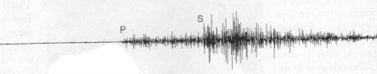

- (5) Using the graph below, about (round to nearest 500 km) how far away is an earthquake station that measures an s-p interval of 2 minutes?

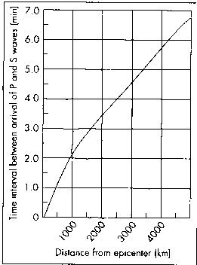

Extra Credit (4): What are the names of the two scales used to measure earthquakes?

