Quiz 7B (20 points possible) Name ________________________
Plate Boundaries Period ______ Date _____________

Write all answers on this sheet of paper. You may use your notebooks.

1. (6) Name 3 things that could cause earthquakes.

2. (4) Label the following on the picture below: continental plate, trench

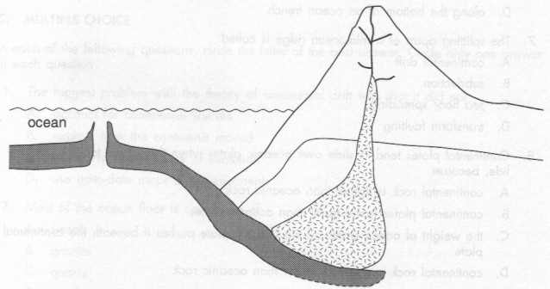

- (4) Draw and label convection currents within the asthenosphere.

- (2) Where are most earthquakes generally found?

- (4) Name two different ways that volcanoes can be formed.

Extra Credit (4): Which of the Hawaiian islands is currently above a hotspot?

