Quiz 4A (20 points possible) Name ________________________
Isotope decay and layers of Earth Period ______ Date _____________

Write all answers on this sheet of paper. You may use only your science notebooks.

1. (4) Which state of matter has the strongest connections between particles?

2. (4) What do geologists believe makes the mantle move?

Use this graph to answer the following questions:

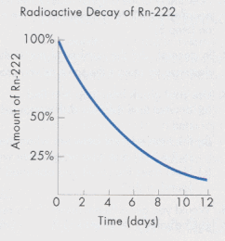

2. (2) What is this isotope's half-life?

- (5) What is the name of the element that is decaying?

- (5) If we start out with 100%, about how much would be left after 7 days?

Extra Credit (4): Which element is named after the messenger god?

