Quiz 4A (20 points possible) Name ________________________
Isotope decay and layers of Earth Period ______ Date _____________

Write all answers on this sheet of paper. You may use only your science notebooks.

1. (4) What do geologists believe makes the mantle move?

2. (4) Which state of matter has the highest temperature?

Use this graph to answer the following questions:

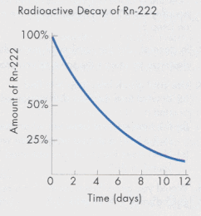

2. (2) What is the name of the element that is decaying?

- (5) What is this isotope’s half-life?

- (5) If we start out with 100%, how long would it take to go down to 25%?

Extra Credit (4): What does inert mean?

