Quiz 3B (20 points possible) Name ________________________
Atoms and Isotopes Period ______ Date _____________

Write all answers on this sheet of paper. You may use only your science notebooks.

1. (3) Which of the 3 particles that make up an atom is the smallest?

2. (1 each: 12 total) Fill in the blanks in this data table (use your periodic table):

Chemical Symbol | Number of protons | Number of electrons | Number of neutrons | Chemical Name
$${\text{Pt}}_{\text{78}}^{\text{197}}$$
$${\text{Ag}}_{\text{47}}^{\text{109}}$$
$${\text{Ti}}_{\text{22}}^{\text{49}}$$

- (2) What kind of charge does an electron have?

4. (3) Which of these fossils is the youngest? Why?
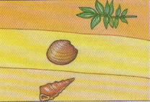

Clam

Plant
Gastropod

Extra Credit (4): What percent of your 1st grade is your notebook worth?

