Quiz 3A (20 points possible) Name ________________________
Atoms and Isotopes Period ______ Date _____________

Write all answers on this sheet of paper. You may use only your science notebooks.

1. (3) What 3 particles make up any atom?

2. (1 each: 12 total) Fill in the blanks in this data table (use your periodic table):

Chemical Symbol | Number of protons | Number of electrons | Number of neutrons | Chemical Name
$${\text{Ag}}_{\text{47}}^{\text{108}}$$
$${\text{Pt}}_{\text{78}}^{\text{195}}$$
$${\text{Zn}}_{\text{30}}^{\text{65}}$$

- (2) What kind of charge does a proton have?

4. (3) Which of these fossils is the oldest? Why?
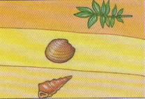

Clam

Plant
Gastropod

Extra Credit (4): What percent of your 1st grade is your notebook worth?

