Oman Survey 2006 - GPS site description

Site Name : HADB

Location: Hadbeen
Long.: 55º 11’ 47’’ E Lat : 17º 13’ 24’’ N Alt: 93m

Benchmark description : small (diameter 12 mm) copper cylinder in basement

Timing : 2 hours from Salalah (160 km)

Notes : May be difficult to find

Site description : From Salalah, take the eastern road to Mirbat. Pass Mirbat, and follow the road along the coast to Sadah and Hadbin. Just before the village HADBEEN, turn left on an asphalt road in front of the pannel indicating Hadbeen and Hasik (55º 12’ 52E , 17º 11’ 55N). In february 2006, a school was being built just before the turn.
Then drive for 3.3 km on the road until the point (55º 12’ 04E , 17º 13’ 22N). You should turn between two triangular signs of dangerous curves. Turn left with a direction N50W. Then you should face a big hill few hundreds of meters in front of you. Pass it by the right. You may pass some old cave houses at 3.5 km. Drive in the Wadi, following the main track. At 3.8 km you go up to the hill, it is very stiff. When up the hill (4 km), you are at the benchmark.

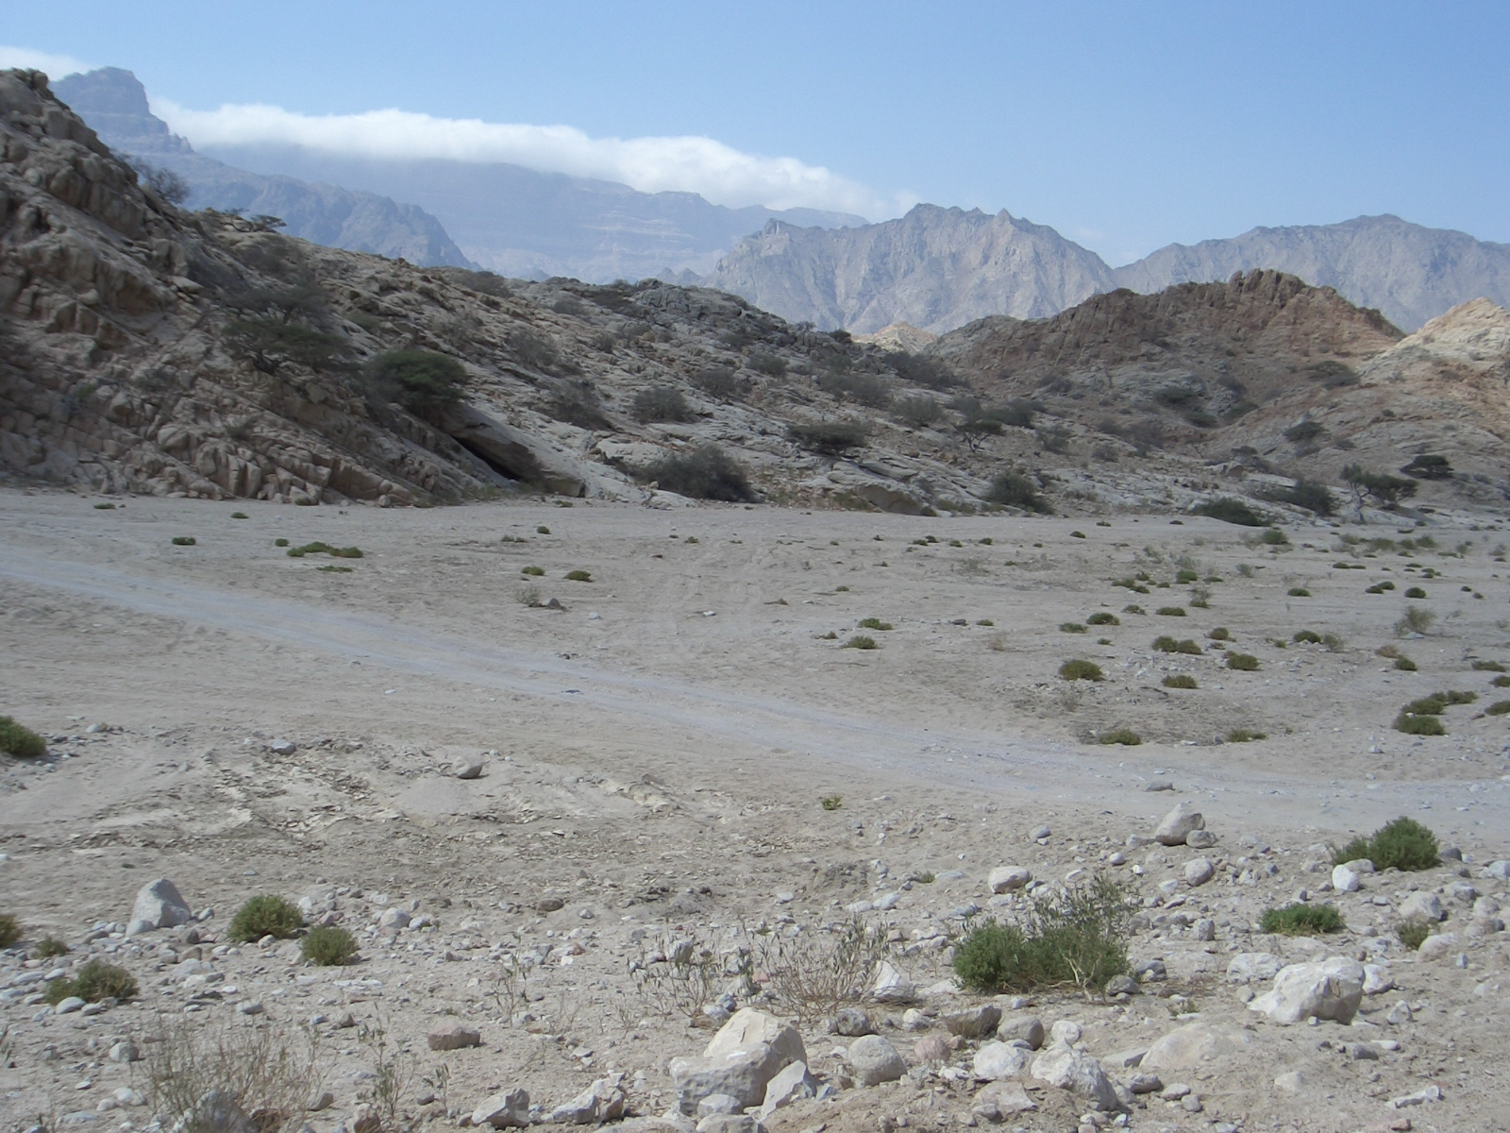
Main road to Hasik + Hadben
To the station
Main track

