San Francisco PSInSAR Study

Final Report
Dataset: ERS DESCENDING
To the attention of:
Prof Roland Burgmann
SEISMO Lab.
University of Berkeley
California
Date: 28 August 2007
Ref: 06.073C

Prepared for:

SEISMO Lab
University of Berkeley
California

Prof. Roland Burgmann

by:

Tele-Rilevamento Europa
Via Vittoria Colonna, 7
20149 Milano
tel: 02.4343.121
fax: 02.4343.1230
http://www.treuropa.com
tre@treuropa.com

Ref:

Engineer entitled of this processing: Fabrizio Novali

Project Manager: Fabrizio Novali

Index

1 Data-Set used for PS analysis: RSAT F4 TRACK 106 4
1.1 Images discarded 5
2 PS report 5
2.1 Information on LOS velocity field and target motion 6
2.2 Velocity Field 6
2.3 Velocity Standard Deviation Field 7

Data-Set used for PS analysis: RSAT F4 TRACK 106

# | Acquisition date | Satellite | Dc * | Bn ^ | Bt [day]
1 | 19920506 | ERS-1 | 0,261 | 0,221057 | -2614
2 | 19920819 | ERS-1 | 0,2476 | 0,014221 | -2509
3 | 19930106 | ERS-1 | 0,2167 | -0,41138 | -2369
4 | 19960329 | ERS-1 | 0,2406 | -0,28869 | -1191
5 | 19960330 | ERS-2 | 0,0649 | -0,37349 | -1190
6 | 19960504 | ERS-2 | 0,0963 | 0,647118 | -1155
7 | 19961130 | ERS-2 | 0,0779 | 0,763051 | -945
8 | 19971011 | ERS-2 | 0,0523 | 0,394099 | -630
9 | 19971220 | ERS-2 | 0,1234 | 0,147887 | -560
10 | 19980404 | ERS-2 | 0,0578 | -0,30341 | -455
11 | 19980509 | ERS-2 | 0,0982 | 0,531348 | -420
12 | 19980718 | ERS-2 | 0,0627 | -0,50944 | -350
13 | 19980822 | ERS-2 | 0,0635 | -0,22801 | -315
14 | 19980926 | ERS-2 | 0,0696 | 0,527276 | -280
15 | 19981031 | ERS-2 | 0,0554 | 0,678675 | -245
16 | 19981205 | ERS-2 | 0,0738 | -0,16291 | -210
17 | 19990109 | ERS-2 | 0,1191 | -0,7142 | -175
18 | 19990213 | ERS-2 | 0,1162 | 0,701335 | -140
19 | 19990320 | ERS-2 | 0,1306 | 0,19668 | -105
20 | 19990424 | ERS-2 | 0,1059 | -0,05017 | -70
21(M) | 19990703 | ERS-2 | 0,0797 | 0 | 0
22 | 19990807 | ERS-2 | 0,0185 | 0,552383 | 35
23 | 19990911 | ERS-2 | 0,0576 | -0,44716 | 70
24 | 19991016 | ERS-2 | 0,0648 | -0,09217 | 105
25 | 19991120 | ERS-2 | 0,0572 | -0,20157 | 140
26 | 19991225 | ERS-2 | 0,1017 | 0,350846 | 175
27 | 20000129 | ERS-2 | 0,1047 | 0,055911 | 210
28 | 20000304 | ERS-2 | 0,3524 | -0,22241 | 245
29 | 20000408 | ERS-2 | 0,0316 | 0,098363 | 280
30 | 20000617 | ERS-2 | -0,3022 | 0,006411 | 350
31 | 20000722 | ERS-2 | -0,3004 | -0,21677 | 385
32 | 20000826 | ERS-2 | -0,2378 | 0,606834 | 420
33 | 20000930 | ERS-2 | 0,051 | -0,19921 | 455
34 | 20001104 | ERS-2 | 0,0174 | 0,157235 | 490
35 | 20001209 | ERS-2 | 0,2154 | -0,28389 | 525
^ Fraction of critical baseline * Fraction of PRF (M) Master scene

Images discarded

Acquisition date | Satellite | Bn ^ | Dc * | Bt [day] | Motivation
19920715 | ERS1 | -0.034 | 0.185 | -2544 | No Data
19951215 | ERS1 | 0.620 | 0.150 | -1296 | No Data
19980817 | ERS2 | -0.132 | -0.044 | -1050 | Bad IFC
19990529 | ERS2 | 0.619 | 0.005 | -35 | Bad IFC
^ Fraction of critical baseline * Fraction of PRF

PS report

Site Name | SAN_FRANCISCO_ERS_D_T70_2853_BERKELEY
Customer | BERKELEY
Reference Documents
Engineer entitled of this processing | Fabrizio Novali
Project manager | Fabrizio Novali

Process Date (final result) | 28/08/2007
Software used | PSproc
Version | 3.0
Analysis type | Standard PS Analysis
Interpolation factor | 2
Satellite data used | ERS
Descending or Ascending Orbit | DESCENDING
Critical Baseline [m] | 1286.86
Pulse Repetition Frequency [Hz] | 1679.02
Number of scenes used | 35
Date range of analysis | 06 May 1992 – 09 December 2000
UTC Time / Local Time | 18:50:32

Reference data used for georeference | LandSat
Projection system used | UTM10 – WGS84
Reference Point location | NORTH: 4147315.99 EAST: 596286.76
Hypothesis on reference point motion | motionless
Extension of the Area of interest | 8700 Kmq
Number of PS identified | 128133
False Alarm Rate | 10⁻⁰⁵
Average PS density (PS/km²) | 14.73

Information on LOS velocity field and target motion

Line Of Sight Versor Coordinates | H: 0.9193 | E: 0.3857 | N: -0.0781
Tilt or phase trends have been removed during PS processing?
Files delivered | SAN_FRANCISCOERS_D_T70_REF.dbf SAN_FRANCISCOERS_D_T70_TS.dbf

Velocity Field
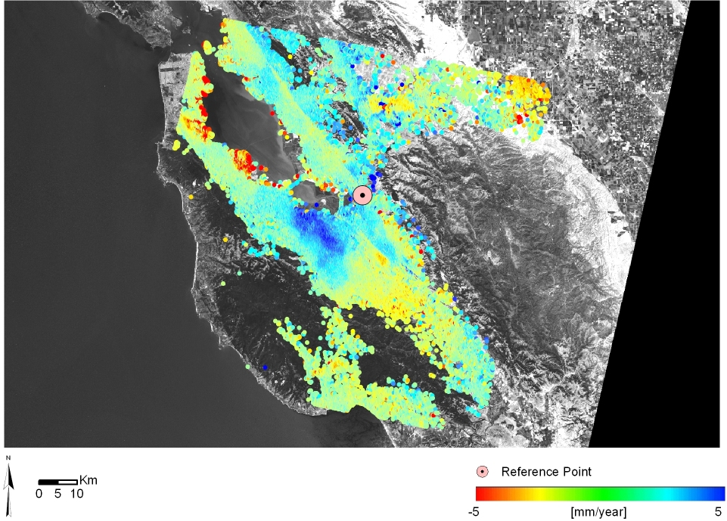

Velocity Standard Deviation Field
