EPS130 – Spring 2008 – Take Home Final Exam

Name__________________

This exam has 7 multipart questions each with equal weight. If there is some uncertainty in the interpretation of the problem clearly define the interpretation that you used in answering. The exam is due Monday May 19 before noon. You may of course turn it in early. Please leave the exam in my Berkeley Seismological Laboratory mailbox on the second floor of McCone Hall, and be sure to put your name on it.

Problem 1: (10 pts) A site is surrounded by three dangerous faults each capable of generating a magnitude 6 earthquake. Fault A has a recurrence interval of 100 years, Fault B a recurrence interval of 200 years, and Fault C a recurrence interval of 500 years.

A) In the next 20 years which has the highest likelihood of occurring.

B) To more fully describe the hazard what is the Poisson probability that 1 or more of these events will occur in the next 20 years.

C) A particularly nervous building owner is very concerned about the possibility that all three events occur in the next 20 years. What is that probability?

D) What is the difference between a Poisson and a Conditional estimate of earthquake probability. What information is needed for a conditional probability estimate?

Problem 2: (10 pts) The 1979 Imperial Valley, California, earthquake can be modeled by a vertical strike-slip fault with length L=35 km, and width W=10 km. The seismic moment has been determined to be 6*10²⁵ dyne-cm. Although there is evidence that the displacement on the fault was non-uniform we assume a uniform displacement fault model in an elastic medium with a shear wave velocity of β=3 km/s and density of 2600 Kg/m³.

Answer the following questions:

- What is the average displacement or offset $\bar{u}$(or $\bar{D}$) on the fault (be careful with units)?

- Since SH waves are the most damaging, given the fault station geometry below, which site (A or B) would be expected to receive the most damaging waves? The two sites are the same distance from the fault. Assume there is no directivity. Explain your answer, and use a sketch to illustrate your reasoning.

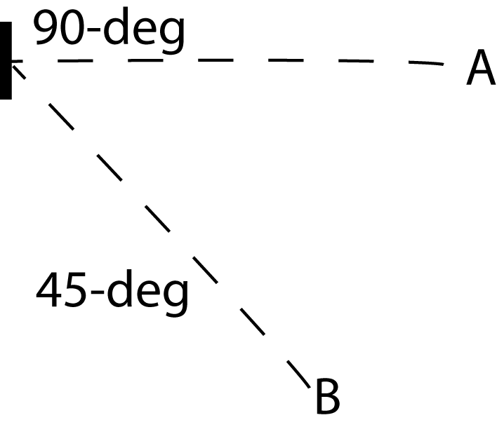

c. Assuming the fault shown in b) ruptures from bottom to top. Describe how this propagating rupture leads to directivity and describe what directivity is. Where is the area of strongest shaking around the fault in this bottom to top rupture scenario?
Problem 3. (10 pts) Suppose that the potential wavefield for a S-wave is defined as
Ψ(x,y,z,t)=<0, -3i, -3i> *ei (ωt + sqrt(3)/2*x – sqrt(3)/2*y – 0.25*z ), where x (east), y (north), and z (up) are the spatial variables and t is the temporal variable, and ω=2.5 radian/second. Use this equation to answer the following questions.

- What direction is the wave propagating in the medium? Use a sketch to illustrate the orientation of the plane wave, and its direction of propagation.

- What are the vertical and horizontal slownesses of the wave?

- What is the wave speed, β?

- What are the amplitudes and directions of the particle displacements for the waves and define the wave types?

Problem 4: (10 pts) Answer the following questions on earthquake statistics.

- If a region experienced 300 M4 events in 10 years how many M6 events likely occurred in the same 10 year period?

- What is the likely recurrence interval for a M7 event given the information in (b)?

- What is a “time-predictable” model? It might be helpful to illustrate your answer with a sketch.

Problem 5. (10 pts) Answer the following ray theory questions.

a) SmS is a potentially strong S reflection from the moho. If we assume the same angle of incidence for SmP will it arrive at the same distance as SmS or at smaller or larger distance?

b) Under what conditions does the phase Sn occur?

c) Assuming a 35 km thick crust with a S wave velocity of 3.6 km/s overlying a 4.5 km/s mantle, and a surface focus event at what distance will Sn emerge as the first arriving S phase?

d) For the same model parameters in (c) at what distance is the SmS amplitude the greatest?

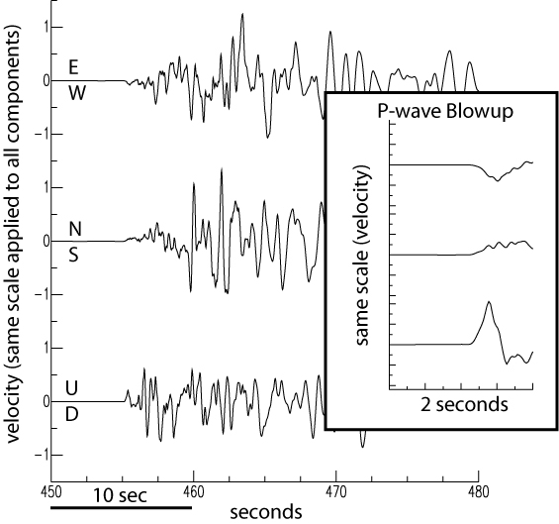

Problem 6: (10 pts) You are the duty seismologist at a lone seismic outpost and just felt a bump in the night. You have only the three-component records shown above to determine the location (distance and azimuth) of the earthquake with respect to your site. Qualitatively describe the measurements that you can make to determine the azimuth and the distance of the earthquake from your site. Quantify your result by labeling the P and S wave arrivals and the corresponding measurements and calculate the azimuth and distance. If you like you may use a graph to illustrate your measurements and how they may be used to determine the azimuth.

Problem 7 (10 pts). The equation, u(t)=S(t)*G(t)*A(t)*I(t), is an application of linear filter theory, which relates the observed seismic displacement time history to a number of different terms. This equation is equivalently u(ω)=S(ω)G(ω)A(ω)I(ω) in the spectral domain, where ω is the angular frequency. For each term on the right hand side of the equation state what the term represents and give a (simple, simplified) mathematical expression for it.

