Exercise 1

Verify that $j(t,r,z)=f(t−R/v)/R$ is a solution to the scalar wave equation in cylindrical coordinates.

Take the Laplace transform of ϕ(t,r,z):
$$L\left\{j(t,r,z)\right\}=L\left\{\frac{f\left(t−R/v\right)}{R}\right\}=f(s)\frac{e^{{−\text{sR}}/v}}{R}=\tilde{j}(s,r,z)$$
We need to show that $\tilde{j}$ can be solution of the P-wave scalar equation and satisfy:
$$\frac{¶^{2}\tilde{j}}{¶s^{2}}−v^{2}\left[\frac{¶^{2}\tilde{j}}{¶r^{2}}+\frac{1}{r}\frac{¶\tilde{j}}{¶r}+\frac{1}{r^{2}}\frac{¶^{2}\tilde{j}}{{\text{¶q}}^{2}}+\frac{¶^{2}\tilde{j}}{¶z^{2}}\right]=0$$
$$\tilde{j}(s,r,z)=f(s)\frac{e^{{−\text{sR}}/v}}{R}=f(s)\frac{e^{−s{\sqrt{r^{2}+z^{2}}}/v}}{\sqrt{r^{2}+z^{2}}}$$
No dependence on θ.

Reminder:
$$\begin{aligned}(f⋅g)'=f'⋅g+f⋅g' \\ (e^{f})'=e^{f}⋅f' \\ (\sqrt{f})'=f'2\sqrt{f} \\ \left(\frac{1}{f}\right)'\text{=-}\frac{f'}{f^{2}}\end{aligned}$$

Let’s work with $\frac{¶\tilde{j}}{¶r}$:
$$\begin{aligned}\frac{¶\tilde{j}}{¶r}=\frac{¶}{¶r}\left[f(s)\frac{e^{−s{\sqrt{r^{2}+z^{2}}}/v}}{\sqrt{r^{2}+z^{2}}}\right]=f(s)\left[e^{{}^{−s{\sqrt{r^{2}+z^{2}}}/v}}\frac{¶}{¶r}\left(\frac{1}{\sqrt{r^{2}+z^{2}}}\right)+\frac{1}{R}\frac{¶}{¶r}\left(e^{{}^{−s{\sqrt{r^{2}+z^{2}}}/v}}\right)\right] \\ =f(s)\left[\frac{−2r}{2R^{3}}e^{{−\text{sR}}/v}−\frac{1}{R^{2}}\frac{2\text{rs}}{2v}e^{{−\text{sR}}/v}\right] \\ f(s)\left[\frac{−r}{R^{3}}e^{{−\text{sR}}/v}−\frac{\text{rs}}{R^{2}v}e^{{−\text{sR}}/v}\right]\end{aligned}$$

Now continue with $\frac{¶^{2}\tilde{j}}{¶r^{2}}$:
$$\begin{aligned}\frac{¶^{2}\tilde{j}}{¶r^{2}}=\frac{¶}{¶r}\left(\frac{\text{¶j}}{¶r}\right)=\frac{¶}{¶r}\left(−\frac{r}{R^{3}}e^{{−\text{sR}}/v}−\frac{\text{rs}}{{\text{vR}}^{2}}e^{{−\text{sR}}/v}\right)f(s) \\ f(s) \\ \end{aligned}\begin{aligned}\left[−\frac{1}{R^{3}}e^{{−\text{sR}}/v}+\frac{3r^{2}}{R^{5}}e^{{−\text{sR}}/v}+\frac{{\text{sr}}^{2}}{{\text{vR}}^{4}}e^{{−\text{sR}}/v}\text{.}\text{.}\text{.} | \right] \\ \end{aligned}$$

And $\frac{¶^{2}\tilde{j}}{¶z^{2}}$ follows the same example:
$$\frac{¶^{2}\tilde{j}}{¶z^{2}}=f(s)\left[−\frac{1}{R^{3}}e^{{−\text{sR}}/v}+\frac{3z^{2}}{R^{5}}e^{{−\text{sR}}/v}+3\frac{{\text{sz}}^{2}}{{\text{vR}}^{4}}e^{{−\text{sR}}/v}\text{+-}\frac{s}{{\text{vR}}^{2}}e^{{−\text{sR}}/v}+\frac{s^{2}z^{2}}{v^{2}R^{3}}e^{{−\text{sR}}/v}\right]$$

Then:
$$\begin{aligned}\frac{¶^{2}\tilde{j}}{¶r^{2}}+\frac{¶^{2}\tilde{j}}{¶z^{2}}=f(s)\begin{aligned}\left[−\frac{1}{R^{3}}e^{{−\text{sR}}/v}+\frac{3r^{2}}{R^{5}}e^{{−\text{sR}}/v}+3\frac{{\text{sr}}^{2}}{{\text{vR}}^{4}}e^{{−\text{sR}}/v}\text{+-}\frac{s}{{\text{vR}}^{2}}e^{{−\text{sR}}/v}+\frac{s^{2}r^{2}}{v^{2}R^{3}}e^{{−\text{sR}}/v}\text{.}\text{.}\text{.} | \right] \\ \end{aligned} \\ \end{aligned}$$
Then the complete expression is:
$$\frac{¶^{2}\tilde{j}}{¶r^{2}}+\frac{¶^{2}\tilde{j}}{¶z^{2}}+\frac{1}{r}\frac{¶\tilde{j}}{¶r}=f(s)\left[\frac{s^{2}}{v^{2}R}e^{{−\text{sR}}/v}\right]$$

We need to come back to the expression: $\overset{¨}{f}−v^{2}Ñ^{2}f=0$
$$\begin{aligned}s^{2}\tilde{j}−v^{2}\left[f(s)\frac{s^{2}}{v^{2}R}e^{{−\text{Rs}}/v}\right]=s^{2}\tilde{j}−f(s)\frac{s^{2}}{R}e^{{−\text{Rs}}/v} \\ \text{and} \\ \tilde{j}=f(s)\frac{e^{{−\text{Rs}}/v}}{R} \\ \text{then} \\ s^{2}\tilde{j}−s^{2}\tilde{j}=0\end{aligned}$$

Exercise 2

Determine the amplitudes of the components of the P and S waves, and the angles describing the wave propagation direction and particle motion.
$$\begin{aligned}j=7e^{2i(0\text{.}5x_{1}+\sqrt{3}⋅x2/2−6t)} \\ Y_{j}=\left\langle \sqrt{3},−1,6\right\rangle e^{3i(0\text{.}5x_{1}+\sqrt{3}⋅x2/2−4t)}\end{aligned}$$

- Let’s start with the P wave: $j=7e^{2i(0\text{.}5x_{1}+\sqrt{3}⋅x2/2−6t)}$
$$\begin{aligned}\vec{u}\text{=Ñ}f+\vec{Ñ}´\vec{y} \\ \text{and} \\ {\vec{u}}_{P}\text{=Ñ}f\end{aligned}$$

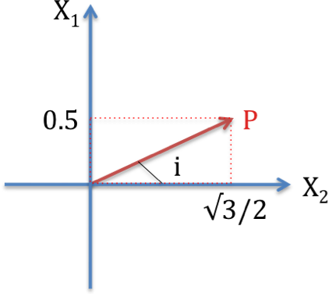
Direction of the wave propagation:
$$\begin{aligned}\underset{\text{amplitude}}{\underbrace{\left\langle 0\text{.}5,{\sqrt{3}}/{2,0}\right\rangle }}=\left\langle N,E,Z\right\rangle \\ \text{tan}(i)=\frac{0\text{.}5}{{\sqrt{3}}/2}=1/{\sqrt{3}} \\ i=\text{30}° \\ \text{azimuth}=N\text{60}°\end{aligned}$$

Particle motion: ${\vec{u}}_{P}\text{=Ñ}f$
$$\begin{aligned}{\vec{u}}_{P}\text{=Ñ}f=\left(\begin{matrix}¶/¶x_{1} \\ ¶/¶x_{2} \\ ¶/¶x_{3}\end{matrix}\right)7e^{2i(0\text{.}5x_{1}+{\sqrt{3}}/2⋅x_{2}−6t)} \\ =\left(\begin{matrix}7⋅2i⋅0\text{.}5e^{2i(0\text{.}5x_{1}+{\sqrt{3}}/2⋅x_{2}−6t)} \\ 7⋅2i⋅\sqrt{3}2e^{2i(0\text{.}5x_{1}+{\sqrt{3}}/2⋅x_{2}−6t)} \\ 7⋅2i⋅0\end{matrix}\right) \\ \text{=<}7i,7\sqrt{3}i,0>e^{2i(0\text{.}5x_{1}+{\sqrt{3}}/2⋅x_{2}−6t)}\end{aligned}$$
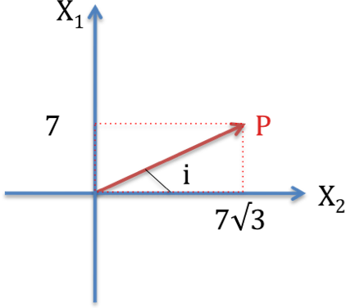
but: $e^{\text{ix}}=\text{cos}(x)+i\text{sin}(x)$
We need to consider the real part only:
$$\begin{aligned}e^{2i(0\text{.}5x_{1}+{\sqrt{3}}/2⋅x_{2}−6t)}=e^{i(x_{1}+\sqrt{3}⋅x_{2}−\text{12}t)} \\ e^{2i(0\text{.}5x_{1}+{\sqrt{3}}/2⋅x_{2}−6t)}=\text{cos}(x_{1}+\sqrt{3}⋅x_{2}−\text{12}t)+i\text{sin}(x_{1}+\sqrt{3}⋅x_{2}−\text{12}t)\end{aligned}$$
Thus:
$${\vec{u}}_{p}=\text{<-}7,−7\sqrt{3},0>\underset{\text{wave}−\text{amplitude}}{\underbrace{}}\text{sin}(x_{1}+\sqrt{3}⋅x_{2}−\text{12}t)$$
tan(i)=7/(7√3)=1/√3
i=30° and azimuth=N60°

- For S wave
$$y_{j}=\underset{\text{wave}−\text{amplitude}}{\underbrace{\left\langle \sqrt{3},−1,6\right\rangle }}e^{3i(0\text{.}5x_{1}+\sqrt{3}⋅x2/2−4t)}$$
tan(i)=0.5/(√3/2)
i=30° and azimuth=N60°

Particle motion:
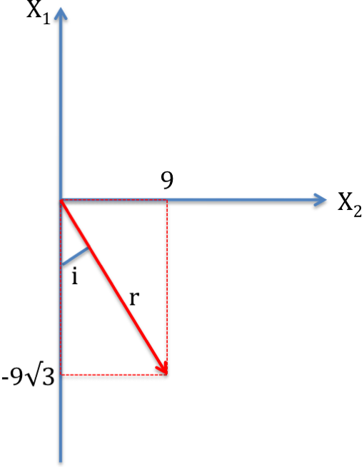
$$\begin{aligned}{\vec{u}}_{s}\text{=Ñ´}y \\ \left(\begin{matrix}{\text{¶y}}_{3}/¶x_{2}−{\text{¶y}}_{2}/¶x_{3} \\ {\text{¶y}}_{1}/¶x_{3}−{\text{¶y}}_{3}/¶x_{1} \\ {\text{¶y}}_{2}/¶x_{1}−{\text{¶y}}_{1}/¶x_{2}\end{matrix}\right)=\left(\begin{matrix}6⋅\sqrt{3}/2⋅3i \\ −6⋅3i⋅0\text{.}5 \\ −1⋅3i⋅0\text{.}5−3i⋅\sqrt{3}⋅\sqrt{3}/2\end{matrix}\right)e^{3i(0\text{.}5x_{1}+\sqrt{3}2x_{2}−4t)} \\ \left(\begin{matrix}9\sqrt{3}i \\ −9i \\ −6i\end{matrix}\right)e^{3i(0\text{.}5x_{1}+\sqrt{3}2x_{2}−4t)}=\left(\begin{matrix}9\sqrt{3}i \\ −9i \\ −6i\end{matrix}\right)e^{i(3/2x_{1}+3\sqrt{3}2x_{2}−\text{12}t)} \\ {\vec{u}}_{s}\text{=<-}9\sqrt{3},9,6>\text{sin}(3/2x_{1}+3\sqrt{3}2x_{2}−\text{12}t)\end{aligned}$$

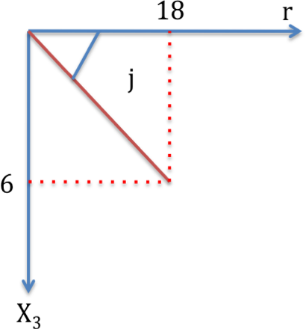
tan(i)=9/(-9√3)=-1/√3
i=-30° => azimuth = N150°
r=√(9² + 9² . 3) = 18

tan(j) = 6 / 18 = 1/3
j ≈ 18.4° => dip, plunge

Exercise 3

Given the amplitudes of the displacements for P and S waves as follows,
$$\begin{aligned}U_{i}^{P}=\left\langle \frac{4}{3\sqrt{2}},\frac{4}{3\sqrt{2}},\frac{4}{\sqrt{3}}\right\rangle \\ U_{i}^{S}=\left\langle −\sqrt{3},−\sqrt{3},\sqrt{2}\right\rangle \end{aligned}$$
The velocities of the two waves are Vp=6km/s and Vs=4km/s, and the angular frequency is ω=4. Find the expressions for the potentials φ and ψi.

- P-wave

$$\begin{aligned}u\text{=Ñ}⋅j\text{+Ñ´}y \\ u_{P}\text{=Ñ}⋅j \\ j(\vec{x},t)={\text{Ae}}^{i(wt±k_{1}x_{1}±k_{2}x_{2}±k_{3}x_{3})}\end{aligned}$$
Let’s consider: $j(\vec{x},t)={\text{Ae}}^{i(wt−k_{1}x_{1}−k_{2}x_{2}−k_{3}x_{3})}$
$$\begin{aligned}u_{P}\text{=Ñ}⋅j \\ \left\langle \frac{4}{3\sqrt{2}},\frac{4}{3\sqrt{2}},\frac{4}{\sqrt{3}}\right\rangle =\left\langle −{\text{Ak}}_{1}i,−{\text{Ak}}_{2}i,−{\text{Ak}}_{3}i\right\rangle \\ \left\langle \frac{−4}{3\text{Ai}\sqrt{2}},\frac{−4}{3\text{Ai}\sqrt{2}},\frac{−4}{\text{Ai}\sqrt{3}}\right\rangle =\left\langle k_{1},k_{2},k_{3}\right\rangle \\ \left\|\vec{k}\right\|=\sqrt{k_{1}^{2}+k_{2}^{2}+k_{3}^{2}}=\sqrt{\frac{w^{2}}{α^{2}}} \\ {\left(\frac{4}{3\text{Ai}\sqrt{2}}\right)}^{2}+{\left(\frac{4}{3\text{Ai}\sqrt{2}}\right)}^{2}+{\left(\frac{4}{3\text{Ai}\sqrt{2}}\right)}^{2}=\frac{4^{2}}{6^{2}}=\frac{\text{16}}{\text{36}}=\frac{4}{9} \\ \frac{−\text{16}}{\text{18}A^{2}}+\frac{−\text{16}}{\text{18}A^{2}}+\frac{−\text{16}}{3A^{2}}=\frac{−\text{64}}{9A^{2}}=\frac{4}{9} \\ A^{2}\text{=-}\text{16} \\ A=4i\end{aligned}$$
Return to:
$$\begin{aligned}\left\langle \frac{−4}{3\text{Ai}\sqrt{2}},\frac{−4}{3\text{Ai}\sqrt{2}},\frac{−4}{\text{Ai}\sqrt{3}}\right\rangle =\left\langle k_{1},k_{2},k_{3}\right\rangle \\ k_{1}=\frac{−4}{3\sqrt{2}⋅4i^{2}}=\frac{1}{3\sqrt{2}}=k_{2} \\ k_{3}=\frac{−4}{\sqrt{3}⋅4i^{2}}=\frac{1}{\sqrt{3}}\end{aligned}$$
then:
$$\begin{aligned}j(\vec{x},t)={\text{Ae}}^{i(wt−k_{1}x_{1}−k_{2}x_{2}−k_{3}x_{3})} \\ j(\vec{x},t)=4{\text{ie}}^{i(4t−\frac{1}{3\sqrt{2}}x_{1}−\frac{1}{3\sqrt{2}}x_{2}−\frac{1}{\sqrt{3}}x_{3})}\end{aligned}$$

- S-wave
$$\begin{aligned}U_{i}^{S}=\left\langle −\sqrt{3},−\sqrt{3},\sqrt{2}\right\rangle \\ u_{S}\text{=Ñ´}y \\ \text{and} \\ y=\left\langle 0,Ω,c\right\rangle \end{aligned}$$
We can separate this S-wave:
$$\begin{aligned}u_{\text{SH}}=\left\langle 0,−\sqrt{3},0\right\rangle \\ \text{and} \\ u_{\text{SV}}=\left\langle −\sqrt{3},0,\sqrt{2}\right\rangle \end{aligned}$$

Let’s work with SV-wave first:
$$\begin{aligned}u_{\text{SV}}=\left\langle −\sqrt{3},0,\sqrt{2}\right\rangle \\ u_{S}=\left\langle 0,Ω,0\right\rangle \\ \text{and} \\ Ω={\text{Ae}}^{i(wt±k_{1}x_{1}±k_{2}x_{2}±k_{3}x_{3})} \\ u_{\text{SV}}=\left(\begin{matrix}¶/¶x_{1} \\ ¶/¶x_{2} \\ ¶/¶x_{3}\end{matrix}\right)´\left(\begin{matrix}0 \\ Ω \\ 0\end{matrix}\right)=\left(\begin{matrix}i & j & k \\ ¶/¶x_{1} & ¶/¶x_{2} & ¶/¶x_{3} \\ 0 & Ω & 0\end{matrix}\right) \\ u_{\text{SV}}=\left\langle ±{\text{Aik}}_{3},0,±{\text{Aik}}_{1}\right\rangle \end{aligned}$$
Take the modulus of the vector:
$$\begin{aligned}{\left(−\sqrt{3}\right)}^{2}+{\left(\sqrt{2}\right)}^{2}={\left(−{\text{Aik}}_{3}\right)}^{2}+{\left(−{\text{Aik}}_{1}\right)}^{2} \\ 3+2\text{=-}A^{2}k_{3}^{2}−A^{2}k_{1}^{2} \\ 5\text{=-}A^{2}\left(k_{1}^{2}+k_{3}^{2}\right)\text{=-}A^{2}\frac{w^{2}}{β^{2}} \\ A=±i\sqrt{5}\end{aligned}$$
Then we can know the vector k:

