Open-Ocean Observatories: Earth Structure and Geodynamics

An ORION Conceptual Proposal

Principal Investigators: R. Detrick, J. Orcutt, D. Chadwell, A. Chave, J. Collins, G. Laske, B. Romanowicz, A. Schultz, R. Stephen, M. Zumberge

Project Summary

To be Written

____________________________________
1. Preface
Long-term continuous open-ocean observations are required for quantifying and understanding interannual-to-decadal changes in ocean circulation, water properties, water mass formation, and ecosystems, for observing episodic events and their impact, for providing reference sites for atmospheric time series and quantifying air-sea fluxes, for quantifying the role of the oceans in the global carbon cycle, for improving images of the Earth’s interior by completing a global network of geophysical observations, and for measuring global plate motions and lithospheric deformation.
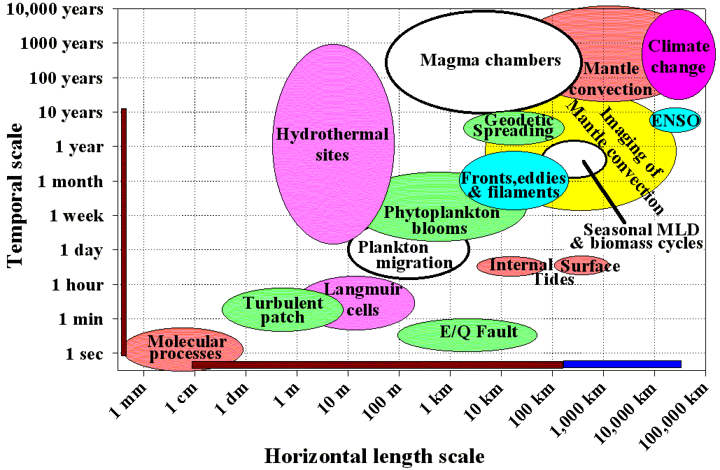
Fig 1. Relationship between temporal and spatial scales of earth and ocean processes Thick brown bars represent scales over which ORION coastal and plate scale observatories will make direct observations, thick blue bar is ORIONís contribution to global observations.
This is one of three coordinated proposals being submitted for interdisciplinary observations at a small number of open ocean sites. This proposal will focus on Earth structure and geodynamics; the other proposals will address climate and air-sea fluxes, ocean circulation and physical processes, biogeochemical cycles, and ecosystem dynamics. Because of the high cost of operating and maintaining time series sites in remote ocean areas there are likely to be only a small number of global stations as part of the ORION program and those sites that serve the largest number of interdisciplinary interests should have the highest priority. We have therefore worked with our colleagues in other disciplines to identify those sites that are of the greatest interest to the broadest cross-section of the ocean science community.
The proposal overlaps with a related proposal “ION (International Ocean Network) Global Ocean Geophysical Observatories” also being submitted to this RFA and which is focused primarily on borehole-based geophysical observatories to complete a world-wide “ocean seismic network” and improve other geophysical coverage. Many of the sites proposed here are also ION sites, including five sites that include borehole instrumentation. However, our focus in this proposal is on identifying ocean observatory sites with the broadest interdisciplinary interest that also contribute to studies of global Earth structure and geodynamics, rather than identifying (borehole) sites whose location is optimized only for global seismology, geomagnetic or tectonic studies.

2. Rationale for a small number of globally distributed geophysical seafloor observatories
Seismology, geomagnetism, electromagnetism, acoustics and geodesy are the main approaches geophysicists use to determine Earth structure and geodynamics. While great strides have been made over the past three decades in using these powerful tools to study the Earth, progress in addressing a number of critical scientific questions has been limited because large gaps that exist in the global network of geophysical observations in the oceans that cannot be filled with island stations (Fig. 2). Although many of the instruments needed to make these measurements exist (e.g. hydrophones, seismometers, magnetometers, pressure sensors, and geodetic instrumentation), the deployment of these sensors in the ocean basins has typically lasted only a few weeks or months, instead of continuously recording over many years, because of the limited power of autonomous, battery-operated instruments and the infrequency with which many remote parts of the world’s oceans are visited by research vessels. The absence of real-time or near-real-time data telemetry to shore has hampered efforts to detect and responds to transient events such as earthquakes, submarine volcanic eruptions or geomagnetic excursions, and precluded remote, in situ repair of instruments that stop operating during long deployments.
The limited sampling of Earth’s interior due to lack of seismic stations in the oceans prevents mapping of much of the core-mantle boundary and lower-most mantle, impedes resolution of mantle plumes, subducting slabs and inner core anisotropy, introduces bias in studies of mantle heterogeneity, and limits resolution of oceanic upper mantle structure. Since the late 1980s the seismological community has repeatedly called for permanent seafloor seismic stations to be broadly distributed throughout the oceans with priority given to stations in the southern Pacific, Atlantic and Indian Oceans where the paucity of seismic measurements is particularly acute because of the scarcity of islands (Purdy and Dziewonski [1988] and Butler [1995]).
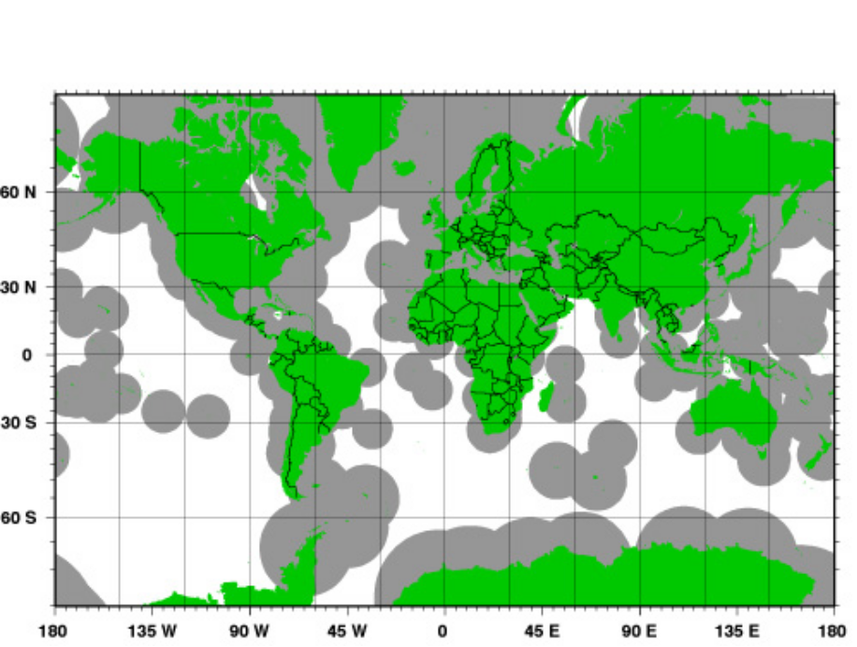
Figure 2: White areas show oceanic areas >1000km from the nearest land or island global seismic station. Note the gaps in coverage in the eastern and southern Pacific, central and southern Atlantic and Indian Oceans.

Inadequate spatial sampling is also a severe obstacle to understanding Earth’s geomagnetic field and electrical conductivity variations in the mantle. The US Geodynamics Committee has noted that even a small number of seafloor geomagnetic observatory sites would provide an improved characterization of the short-term behavior of the Earth’s magnetic field, and the 3-D variation in the mantle’s electrical properties not possible with the incomplete sampling from existing continental and island stations. Supplementing magnetic observatories with electric field sensors would further improve resolving power in the upper-most mantle. Sampling durations of decades are desirable to investigate phenomena such as core torsional oscillations, changes in core angular momentum, and accelerations of the magnetic field (“jerks”).
Fixed seafloor observatories can also serve as scientifically important long-term measurement sites for geodetic and tectonic studies of global plate motions and crustal deformation. Seafloor geodetic measurements can directly measure crustal deformation along plate boundaries, as well as constrain larger scale plate motions. Acoustic monitoring can detect and locate earthquakes that cannot be resolved by land-based networks. Finally, seismic and acoustic stations in the oceans provide needed directional coverage of seismic activity for understanding earthquake sources in the oceans and on land proximal to the oceans, and assessing hazards from tsunamis.

3. Role of Ocean Observatories
The OOI will provide the power, bandwidth and two-way communication to instruments on the seafloor in regions far from land that is needed to fill critical gaps in existing land-based global geophysical coverage. Without the sustained commitment to long-term observations at these sites provided by the ORION program, it is unlikely that these observational gaps will ever be filled by “business as usual”, ship-based expeditionary studies. The global coverage of geophysical observations enabled by the OOI and ORION will provide much-improved images of deep earth structure, magnetic field behavior and global geodynamics (see Section 5 of this proposal).
While autonomously recording, portable instruments could be deployed for periods of a few months to a year or two to fill these gaps in global geophysical coverage there are distinct disadvantages to this approach. First, the signal levels associated with some phenomena (e.g., accurately mapping departures from Earth’s spherical symmetry; determining the motions of tectonic plates; characterizing secular variations in Earth’s magnetic field) are small compared with the background noise and require measurements over long time periods (many years to a decade or more) just to resolve a signal. Second, without real-time or near-real-time data telemetry it is impossible to know if autonomously recording instruments are properly functioning until after they are recovered. The two-way telemetry provided by an OOI node will allow continuous assessment of data quality and instrument functionality, and provide the opportunity to remotely “repair” an instrument by commands sent from shore. IRIS has found that seismic stations that have real-time or near-real-time telemetry have greater “up time” and higher data quality than autonomously recording stations. Autonomously recording instruments will have to be recovered and redeployed annually to retrieve data and replace battery packs. Instruments powered by the node, or that are equipped with battery packs that can be serviced by an ROV, will not have to be recovered and redeployed annually so sensor orientation and noise characteristics will be the same year after year.
The utilization of a few high-quality ‘permanent’ stations and larger numbers of instruments in portable arrays deployed campaign style has been enormously successful in regional and global geophysical studies on the continents. This same approach holds great promise in the oceans, and the OOI will finally provide the means for marine geoscientists to pursue this strategy.

4. Identifying Global Time Series Sites of Interdisciplinary Interest
The international, interdisciplinary Ocean SITES group, successor to the Time Series Science Team (TSST), coordinates the planning efforts of many of the groups interested in the science questions that can be addressed by the establishment of fixed, time series sites in the open ocean (see http://www.oceansites.org/OceanSITES/ ). The TSST was formed by CLIVAR and GOOS (through the CLIVAR Ocean Observations Panel and the GOOS Ocean Observations Panel for Climate), and endorsed by Partnership for Ocean Global Observations (POGO) to represent the ocean community’s diverse scientific interests. Its membership is multidisciplinary, including geological, biological, chemical, and physical scientists whose interests extend from the ocean bottom to the air-sea interface. They have identified a number of potential sites located at the intersection of regions of interest for multiple disciplines. Priority has been given to those sites where a shared interdisciplinary infrastructure will provide cost-effective observing systems that should be affordable and functional for decades to come.
We have used the site list developed by the TSST (see Appendix E of the National Research Council report Enabling Ocean Science in the 21st Century, 2003) as a starting point to identify thirty sites of potential interdisciplinary interest for ORION’s global network. The PIs from the three coordinated proposals mentioned in the Preface (F. Chavez; R. Detrick, J. Orcutt, U. Send, J. Toole, R. Weller), each chose and ranked 15 high priority sites from the list of 30 sites in four different areas: air-sea flux, biogeochemistry, geophysics, and ocean circulation and climate (1=highest priority; 15 lowest priority). The complete list of 30 sites with their rankings are listed in Table A-1 in the Appendix and plotted in Figure A-1. In assigning the geophysical priorities for these sites, we relied primarily on sites recommended by the International Ocean Network (ION) program (see http://seismo.berkeley.edu/seismo/ion/) whose primary focus is on completing a global network of geophysical observations by establishing seafloor observatories in regions that are >1000 km from the nearest land stations (Fig. 2).
Based on the disciplinary rankings of these 30 sites we identified eleven sites of highest interdisciplinary interest. These sites are listed in Table 1 in priority order and shown in Figure 3 numbered 1-11. All eleven sites are of interest to at least three of the four disciplinary groups. Three of the four highest priority sites are in the southern hemisphere. Three sites are at latitudes of 50° or higher (1 in southern hemisphere; 2 in northern hemisphere). There is a good balance among these fifteen sites – they include 5 of the top 10 geophysics sites; 7 of the top 10 air-sea flux sites; 6 of the top 10 ocean circulation/climate sites, and 6 of the top 10 biogeochemistry sites. They include three established time series sites (BATS, HOT and Station Papa), but also include a number of sites in remote ocean areas that are rarely visited or studied.
In addition to these eleven interdisciplinary global sites, we also have identified five additional global sites of very high priority geophysically, but that are a lower priority for some other disciplines (Table 2). This includes establishing a borehole observatory at ODP1243 in the eastern equatorial Pacific, geophysical observatories at high southern latitudes in the Pacific and Indian Oceans, as well as additional sites in the North and South Atlantic (see Fig. 3). We believe there is a strong justification for occupying these sites based on geophysical scientific objectives alone, and at some sites there is significant interdisciplinary interest as well (see rankings in Appendix Table A-1).

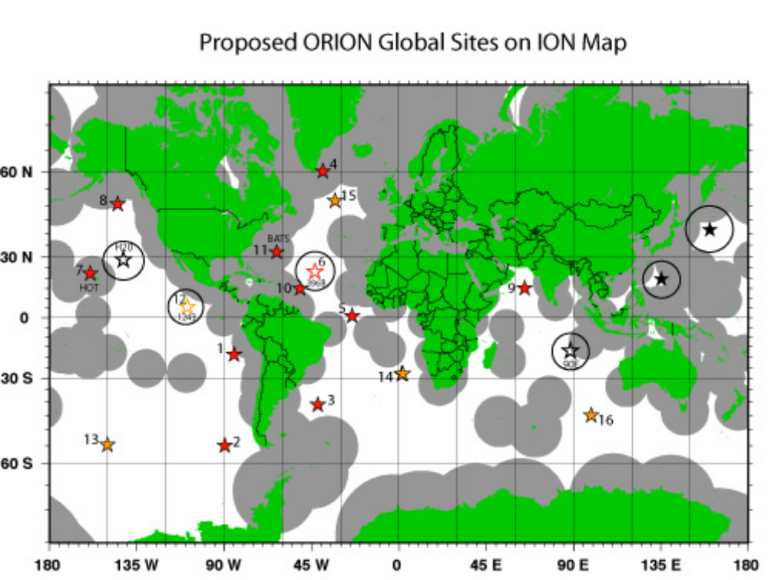
Figure 3: Location of proposed ORION global sites (red and orange stars) superimposed on ION map showing in gray those areas within 1000 km of an existing Global Seismic Network sites. Sites are numbered as in Tables 1 and 2. Red stars are proposed ORION interdisciplinary global sites; orange stars are additional high priority geophysical global sites. Solid black stars are operating Ocean Seismic Network borehole observatories (WP1: Philippine Sea; WP2: Northwest Pacific) operated by Japan. Four unfilled stars (90E Ridge, H20, DSDP 396B; ODP 1243) are existing boreholes proposed as OSN sites but are not yet instrumented. We are proposing two of the sites (DSDP 396B, ODP 1243) as interdisciplinary ORION global sites.

5. Scientific Objectives and Hypotheses
A small number of globally distributed geophysical observatories on the seafloor, such as those shown in Fig. 3, will allow a number of fundamental scientific questions to be addressed in global seismology, Earth structure and geodynamics, geomagnetism and plate dynamics.

5.1 Global Seismology, Earth Structure and Geodynamics
The IRIS Global Seismographic Network (GSN), in conjunction with the international Federation of Digital Seismographic Networks (FDSN) has the objective of distributing 128 stations over the surface of the globe. In 1984, during the preparation of the Science Plan for the Global Seismographic Network (GSN), reviewers pointed out that a network can not be ‘global’

Table 1 Proposed ORION Global Interdisciplinary Sites
Site | Location | Lat. | Long. | Air-Sea  Flux | Biogeo-  chem | Geophys | Ocean  Circ. | Comments
1 | Pacific | 18°S | 85°W |  |  |  |  | Peru Basin; existing air-sea flux site; near OSN phase site on the Nazca plate
2 | Pacific | 55°S | 90°W |  |  |  |  | Southern Ocean; AAIW formation; meteorology; CO2; plume imaging beneath Pacific Superswell
3 | Atlantic | 42°S | 42°W |  |  |  |  | Brazil/Argentine Basin; biogeochem; ocean circ.; improve global geophysical coverage
4 | Atlantic | 60°N | 39°W |  |  |  |  | East Greenland; ocean circ.; climate; biogeochem.
5 | Atlantic | 0° | 23°W |  |  |  |  | PIRATA mooring; equatorial Atlantic; biogeochem; ocean circ; CMB imaging
6 | Atlantic | 23°N | 44°W |  |  |  |  | ODP 396B; proposed OSN site; meteorology; biogeochemistry
7 | Pacific | 22.7°N | 158°W |  |  |  |  | HOT (Hawaii Ocean Time Series) site; Pacific plate structure; tsunamis
8 | Pacific | 50°N | 145°W |  |  |  |  | Station PAPA; NE Pacific; subduction zone dynamics; tsunamis
9 | Indian | 15°N | 65°E |  |  |  |  | Arabian Sea; monsoon; global geophys. coverage
10 | Atlantic | 15°N | 51°W |  |  |  |  | Existing Northwest Tropical Atlantic Station (NTAS); CMB imaging
11 | Atlantic | 32°N | 64°W |  |  |  |  | BATS (Bermuda Atlantic Time Series Site)
Boxes with  indicate site is a priority site for that discipline

Table 2 Additional High-Priority Global Geophysics Sites
Site | Location | Lat. | Long. | Comments
12 | Pacific | 5 °18’N | 110° 6’W | Equatorial eastern Pacific; OSN2/ODP1243 borehole
13 | Pacific | 55°S | 150°W | Southern Ocean/Pacific; improved lower mantle imaging
14 | Atlantic | 28°S | 2°E | Walvis Ridge, 2°E; global geophys. coverage
15 | Atlantic | 51°N | 33°W | Northern Mid-Atlantic Ridge; Iceland plume
16 | Indian | 45°S | 99°E | Southeast Indian Ridge; global geophys. coverage

without including observations from the ocean bottom, as the oceans cover some 70 percent of the Earth's surface. At that time, the technology required to establish and maintain permanent observatories on the seafloor did not exist, and it seemed expedient to proceed with the establishment of the land-based network that would make use as much as possible of oceanic islands, even though these are, by definition, anomalous structures. This undertaking has been very successful – as of the end of 2004 there were 137 IRIS-operated seismic stations as part of the GSN. However, some 80% of this instrumentation is in the northern hemisphere, and there are areas of several thousand kilometers in dimension without a single seismographic station (Fig. 2).
Improved spatial sampling provided by long-term observations in the oceans promises great gains in the field of seismology [Purdy and Dziewonski, 1988]. The absence of seismic stations in the Southern Ocean is particularly acute because of a lack of islands and results in much poorly resolution of mantle structure in the southern hemisphere. Improved spatial sampling provided by long term, broadband seismic stations at even a small number of carefully chosen sites would provide much improved tomographic imaging of the structure of the lower mantle and the core-mantle boundary, and the role of subducting slabs and plumes in deep mantle circulation. Seismic observations in locations such as the northwestern Pacific or Nazca plate would provide an important tool for understanding earthquakes, and assessing seismic hazards, in some of the world’s most active subduction zones.
Fundamental questions long-term seismic observations in the oceans can address include:

What is the fate of subducting slabs and the origin and scales of mantle heterogeneity?
One of the most important and longstanding questions in geodynamics is the pattern of convection in the Earth’s mantle, and the origin and scales of mantle heterogeneity. The chemical heterogeneity revealed by isotope and trace element studies of volcanic rocks seems to require that the mantle is stratified into isolated layers or that mantle convection does not efficiently mix chemical heterogeneities, or some combination of these processes [Albarède and van der Hilst, 2002]. For many years it was thought that the upper and lower mantle represented distinct geochemical reservoirs. However, over the past decade advances in seismic tomographic imaging has shown that some subducting slabs extend well into the lower mantle, casting doubt on a layered convective model [e.g. Grand et al. 1997]. How far these slabs penetrate into the lower mantle, and the rheology of lithospheric material once in the lower mantle, are matters of active debate. In some cases slabs appear to be confined to the upper mantle. In other cases they appear to sink deep into the lower mantle although they often “fade away” in tomographic images well above the core-mantle boundary. It is unclear, however, whether slabs don’t extend below this depth, or whether this is an artifact of poor seismic resolution in the lowermost mantle. This question can only be resolved if mantle heterogeneity can be determined with confidence at scale lengths smaller than 1000 km in a global sense and this requires seafloor observations. Proposed sites 3, 5, 6, 10 and 14 will significantly improve imaging of the subducted plats of the Americas in the southern hemisphere.

What is the origin of hotspots and their role in the global circulation?
Another currently very controversial issue in mantle dynamics is the origin of “hotspot” volcanism - like that which occurs in Iceland, Hawaii and the Pacific superswell. In particular, there are widely varying views on whether hotspots rise as narrow hot jets off a thermal boundary layer, such as the core-mantle boundary, whether they form at various depths in the mantle, or whether this volcanism is caused by shallow lithospheric-scale processes [Kellogg et al., 1999; Anderson, 2001]. Because mantle plumes are relatively narrow, with diameters on order of a few 100 km at most, imaging plumes using conventional seismic tomographic techniques with data from only continental or island stations has been problematic. Even a small number of seafloor seismic stations located in regions without islands (e.g. the South Pacific between Chile and New Zealand) would significantly improve our ability to image plume conduits and subducting slabs in the mid- and lower mantle in the Pacific and address these 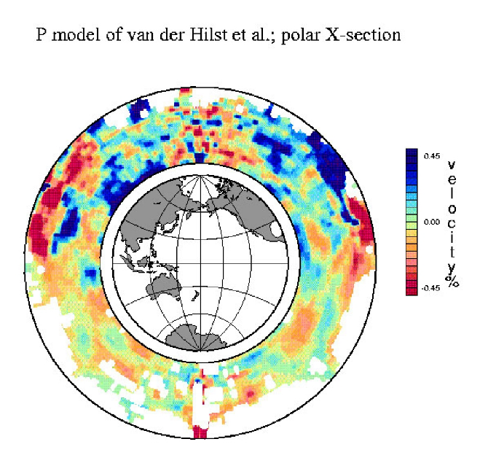important questions regarding mantle dynamics. Sites 1, 2, 7, 8, 12 and 13 will all significantly improve imaging of plumes in the Pacific while sites 6, 10 and 15 will improve imagining of plumes in the North Atlantic.
Figure 4: Polar tomographic cross section of a high-resolution study of the mantle from van der Hilst et al. (1997) showing lack of resolution of seismic structure in the southern hemisphere.

What are the properties of the core-mantle boundary and lowermost mantle? The core-mantle boundary plays a critical role in regulating heat flow from the core to the mantle, thereby influencing convection in the core and the dynamo that generates the earth’s magnetic field. The CMB also plays an important role in mantle convection - it may be the source of at least some mantle plumes and may act as a reservoir for long-lived geochemical heterogeneities. Recent studies of the CMB have found evidence for extremely low seismic velocities, dubbed Ultra-Low Velocity Zones (ULVZ), but it is not clear what these features are. One clue about their origin comes from where they are found. The ULVZs appear to correlate with an area of widespread volcanism known as the South Pacific Superplume and they don’t seem to occur where subduction of the ocean lithosphere is occurring [Thorne et al., 2004]. However, coverage of CMB properties is very incomplete largely because of a lack of stations in the oceans, and as a result, these ideas remain very speculative. The Tonga Trench and other subduction zones in the western Pacific are the source of the most abundant large, deep earthquakes on Earth, and consequently are nearly ideal sources for studies of the core-mantle boundary beneath the Pacific. However, the seismic waves from these events that sample the CMB beneath the Pacific can only be recorded at sites in the central equatorial Atlantic. A small number of seafloor seismic stations in the central Atlantic Ocean would significantly improve our ability to resolve the structure of the Earth’s outer core and core-mantle boundary. Sites 5, 6 and 10 are ideally situated to record compressional phases off the CMB from earthquake sources in the Tonga-Kermadec trench.

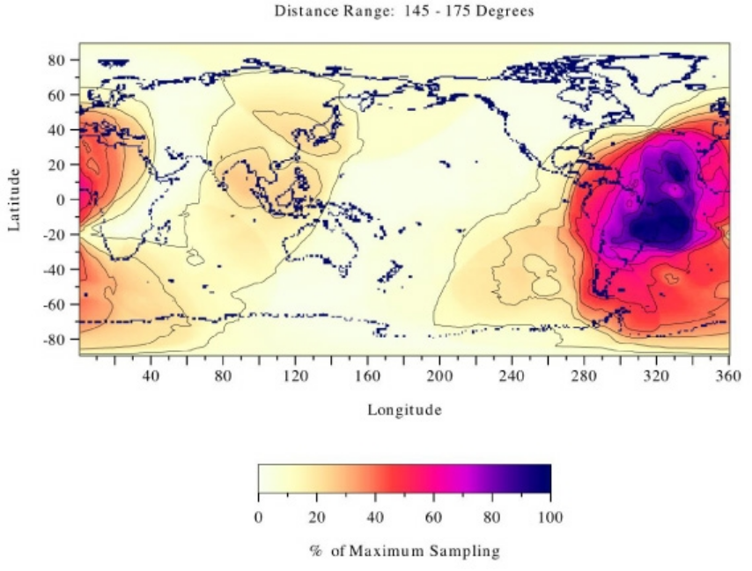
Figure 5. Sampling distribution as a function of location for events in the epicentral range 145°-170°. This is the distance range where the various PKP core phases emerge. The values at each location show the percentage of earthquakes that would be recorded in this distance range, normalized to the maximum coverage. This figure shows that core phases are best sampled in the central Atlantic ocean. [from Wyession, 1996].

What is the structure of Earth’s inner core?
The inner core of the Earth is the final frontier for solid Earth geophysics. It has been the object of intensive studies in recent years and some unexpected results. The anisotropy of the inner core and the measurement of its differential rotation with respect to the mantle have been among the more celebrated results from seismology in the last decade or so. But there is a great deal of uncertainty that has to be attached to the results for this region. Inner core anisotropy has been proposed to explain faster propagation of PKP phases on polar paths compared to equatorial paths, as well as anomalous splitting of core sensitive normal modes [Morelli et al., 1986; Woodhouse et al., 1986; Shearer et al., 1988]. Simple models of constant transverse anisotropy can explain the data to first order. However, as high quality broadband data have accumulated, a high level of complexity has emerged with hemispherical variations in the trends of PKP travel times [e.g. Creager, 1999], as well as evidence for layering of anisotropy within the inner core. For example, very anomalous paths along the South Sandwich Island to Alaska path cannot be explained by any simple model of the inner core and the inner core origin of these anomalies have been questions [Bréger et al., 2000]. The picture is complicated byuneven distribution of observations on polar paths combined with possible heterogeneity in the outer core , perhaps distributed as “sediments” in the immediate vicinity of the core-mantle boundary [Rost and Revenaugh, 2001]. To distinguish the relative contributions of core-mantle boundary structure, outer-core heterogeneity and inner-core anisotropy a much more uniform sampling of polar paths around the Earth is needed which will require stations in the northernmost and southernmost oceans.

Plate-scale properties, regional tectonics and earthquake fault mechanics
To first order, many important predictions of plate tectonic theory have long been verified through seismological observations in the ocean, e.g. the thickening of the oceanic lithosphere with age as inferred from surface-wave dispersion data (e.g. Nishimura and Forsyth, 1989), and the alignment of the fast axis of azimuthal anisotropy perpendicular to the mid-ocean ridge system (e.g. Montagner and Tanimoto, 1991). However, some recent observations, mostly made possible by the increased quality of broadband seismic data collected on land in the last 10 years through the efforts of the GSN, indicate significant and puzzling departures from the simple plate tectonic model. This is particularly notable for the fast-spreading Pacific plate. For example, the fast axis of azimuthal anisotropy changes direction significantly at some distance from the ridge in the central Pacific. This may somehow be related to secondary convection in the upper mantle [Montagner, 2002], which was proposed originally to explain the relatively high heat flow measured on old oceanic floor. The length-scale of this convection would be on the order of several hundred kilometers, and it is not clear even now whether the convection cells are aligned perpendicular or parallel to the ridge system. The thickening with age of the oceanic lithosphere is itself being questioned: it is not equally visible in Rayleigh and Love fundamental-mode surface-wave data, as the signal is complicated by the presence of significant transverse isotropy, with horizontally polarized S waves traveling faster than vertically polarized ones, in the central Pacific (e.g. Ekström and Dziewonski, 1998). Broadband seismic stations at an even small number of sites in the Pacific basin could provide fundamental new insight into these questions.
Seismic and acoustic networks are also indispensable for studying earthquakes and tsunami generation, as well as understanding regional structure and tectonics. The deployment of autonomous hydroacoustic “T-phase” arrays, by NOAA’s Pacific Marine Environment Laboratory (PMEL) [Fox et al., 1993], has resulted in the lowering of oceanic earthquake detection thresholds from about magnitude 5 to magnitude ~2-3 for most areas within about 1000 km of the arrays [Fox et al., 1993; Fox et al., 2001; Bohnenstiehl et al., 2002], and reduced the uncertainty in epicenter locations to a few kilometers or better for events located inside the arrays. We propose to deploy a broadband hydrophone mooring in the SOFAR channel at each site. The data acquired with these moorings will result in a significantly better determination of the broad scale spatial and temporal patterns of oceanic seismicity. T-phase catalogs have also been shown to be useful for studying the physical processes involved in oceanic earthquake rupture [Bohnenstiehl et al., 2002; McGuire et al., 2005]. Owing to the relatively fast plate motion rates and the small size of the largest earthquakes (say M 6.0 on the Kane transform fault at 24ºN at the MAR), T-phase catalogs (if continued) will soon become the first “instrumental catalogs” to span multiple earthquake cycles on a particular fault. They will become a natural dataset for testing models of fault/earthquake evolution.
The catastrophic Dec. 26, 2005 Sumatra earthquake has highlighted the need for real-time tsunami warning throughout the world’s oceans. We will deploy at each site a high-resolution depth sensor (e.g. Paroscientic depth sensor) of the type used by the NOAA Deep Ocean Assessment and Reporting of Tsunamis (DART) Project [Milburn et al., 1996; Gonzalez et al., 1998]. These deployments will complement the current and future NOAA arrays. The data logger will run a tsunami detection algorithm similar to that developed by NOAA and a protocol will be established whereby a detection will be flagged with the highest priority for telemetry ashore.

5.2 Geomagnetism
The global geomagnetic observatory network is the oldest worldwide, internationally-coordinated observatory system, predating the mid-19th century. The length and quality of geomagnetic time series provides Earth scientists with an exceptional resource for studying geodynamic processes, yet the geomagnetic community is hampered severely by the biased spatial sampling inherent in a system devoid of seafloor stations. To achieve their full potential, such seafloor stations must be operated on decadal scales or longer, and comply as closely as possible with international standards as defined by the INTERMAGNET consortium. Presently of the approximately 200 observatories operated around the globe, 92 stations in 39 countries are run to INTERMAGNET standards. We propose to adhere as closely as possible to these standards. In practical terms this means the permanent seafloor (electro)magnetic observatory installations must be provided adequate power so they may use sensors capable of establishing stable baseline measurements of the geomagnetic field rather than variations about an unknown and drifting baseline value, and they must support near real-time telemetry. ORION, and the infrastructure OOI will provide, makes this possible.
The recognition of the importance of a seafloor element to such large-scale observatory efforts can be traced to many sources. As summarized in the SCOTS Report (2002) with regard to cabled, seafloor electromagnetic observatories:

“In the geomagnetism realm, we don’t really know what causes Earth’s magnetic field to reverse. Magnetic and electrical data from remote areas of the Earth would help us find out. (2) What are the properties of the core-mantle boundary? Is the layer directly above this boundary the source of mantle plumes and hot spots? Is it the graveyard for subducted plates? Are the long-wavelength geoid anomalies created by undulations in the core-mantle boundary? (3) What is the extent and structure of mantle convection? How is convection modified by subducted slabs? How much coupling is there between the tectonic plates and convection in the mantle? What is the role of mantle plumes in convection? What is the role of lithospheric roots under continental blocks in convection? How rapid is convection? How complete is mantle mixing?”

The SCOTS report was not the first to recognize that real-time seafloor observatories would be a major component of future EM research. US National Research Council studies spanning more than a decade have concluded such a capability was required (NRC 2000, 2003; National Geomagnetic Initiative 1993). Clark (2003) and the DEOS Global Working Group (1999) made similar recommendations.
Investigations providing stable measurements of the Earth’s internal geomagnetic field and views of electrical conduction in the oceanic mantle can address the geodynamic questions summarized above, and can also provide data complementary to other investigations of relevance to ORION. The proposed global seafloor (electro)magnetic observatory array accomplishes several long-term objectives. First, it substantially reduces the geographic bias found in the existing continental, and northern hemisphere-centric global observatory distribution, making it possible to construct models of the internal and internally-induced geomagnetic fields to spherical harmonic degree and order 8-10, globally. Regionally, it will be possible to extend to even higher order harmonics. This will permit us to refine our existing 3-D models of the variation of electrical conductivity of the mantle, to provide a spatial resolving power capable of resolving the large-scale features of mantle convection processes. This will also provide a set of deep “anchor points” about which higher-resolution regional-scale studies may be conducted.
On the plate scale, the pattern of spatial variability in electrical conduction within the lithosphere and asthenosphere is governed by convection beneath the plate, the upwelling of mantle materials beneath the ridge crest, and the subduction and recycling of the slab into the mantle. This pattern is mapped into electrical conductivity through the sensitivity of mantle and crustal electrical conduction to temperature, composition, degree of partial melt, presence of fluids and volatiles. By mapping out the 3-D variations of electrical conductivity in the mantle, we can construct models of the geodynamical processes that underlie these observations. Such data are complementary to seismic methods. Seismic interpretation leads to constraints on the elastic properties and the density of Earth materials, rather than the electrical properties of those materials. ORION therefore provides a powerful tool, enabling joint interpretation of EM and seismic models, since our stations will be collocated with broadband seismometer sites.
This proposal complements international activity in magnetic field satellite missions. Approximately a half dozen international magnet satellites have operated over the past decade, and more are in the pipeline both for pure research, and for applications including national security. Permanent seafloor magnetometry also aids interpretation of aero and marine magnetic studies of crustal magnetization, both onshore and offshore, providing stable baseline measurements of immediate utility to these investigations. The proposed EM observatory sites will provide important new information on the internal magnetic field, of great use to studies of the circulation of outer core fluids driving the geodynamo, and of research in coupling between the geosphere and hydrosphere of relevance to studies of climate change. These research areas are enumerated below.

Electromagnetic Induction Imaging of the Mantle.
Convection of the mantle is the underlying mechanism that drives plate tectonics – yet the controls on thermal and compositional convection, as well as the chemical variability within the mantle remain poorly understood. The heterogeneity detected in mantle electrical conductivity, and the correspondence between patterns of heterogeneity and tectonic regime, has stimulated the development of new analytical and numerical tools for modeling the mantle. The effort to construct a 3-D view of the mantle’s electrical properties (e.g. related to temperature, composition, volatiles, melt) is in transition. The earliest models were based on the datasets of the mid-1980’s. These data were limited in both geographical distribution, and interpretation. Despite these limitations, the first 3-D mantle conductivity models (Schultz & Pritchard, 1998) show remarkable similarity to shear wave tomographic velocity distributions. There is no a priori reason why these very different approaches should provide a mutually coherent picture. That they do implies that important new bounds on mantle conditions should, in future, arise from joint interpretation of seismic tomography and 3-D electromagnetic induction imaging.
New methods of modeling (Uyeshima & Schultz, 2002; Kuvshinov et al, 2005; Velimsky & Martinec, 2005) and of extracting information from the geomagnetic fields have been developed more recently (Fujii & Schultz, 2003) that now make it possible to model the electrical structure of the mantle in 3D from pole-to-pole, with a quality that depends on the spacing between observatory points on the Earth’s surface. Our ability to extract higher resolution views of 3-D mantle conductivity structure is no longer limited by theory – only by the absence of adequate global coverage. It is essential that INTERMAGNET-compliant electromagnetic observatory systems be installed on the seafloor.
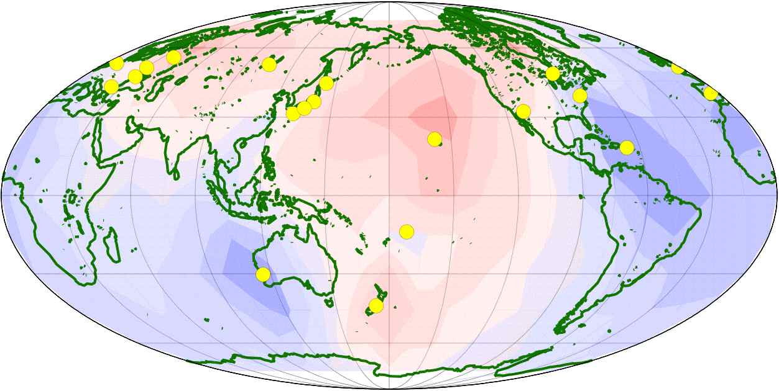
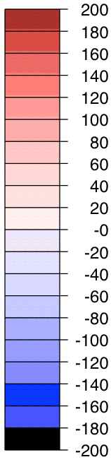
Fig. 6. Variation of mantle conductivity for 2nd of 4 shells in Schultz & Pritchard (1999) model, shell depth of 436-774 km. Color represents % perturbation around baseline of 0.31 S/m ñ red is conductive, blue is resistive. Yellow dots are locations of magnetic observatories used in this study.
Passive seafloor electromagnetic observations (magnetic plus electric field) have been carried out at on the seafloor at basin sites and also along a number of mid-ocean ridge systems. We propose to augment permanent magnetic observatories with electric dipole receivers. This can be done at low marginal cost, and provides an additional data set that can be used to provide higher resolution data in the upper-most mantle immediately beneath the observatory site. While the utility of electric field measurements for sub-seafloor electrical investigations is frequency band-limited at long periods by the EMFs generated by water motions, and at short periods by the electromagnetic shielding effects of the conductive water column, it should be feasible to strip off motional induction effects and to extend the useful frequency band for conductivity investigations into longer periods for those observatories collocated with physical oceanographic measurements. At those sites, mesoscale water motions can be modeled, and the EM effects of those motion removed from the (electro)magnetic observatory data.

The Geodynamo and Geomagnetic Field.
While we have long known that the Earth's magnetic field is largely of internal origin, there are fundamental gaps in our understanding of the dynamo process that generates that field. Understanding the changes in the geomagnetic field over the annual-to-decadal scale is important for a broad range of problems in Earth science of interest to a wide community. Examples include geochemical interests in the variation in the rate of production of beryllium and carbon isotopes in the upper atmosphere by cosmic rays that result from variations in the intensity of the geomagnetic field. Understanding changes in the angular momentum of the core is important if we are to remove the contribution to the total angular momentum of the Earth system due to the core, so that long term variations in the angular momentum of the hydrosphere can be isolated. This provides a possible marker of the effects of global change on the hydrosphere. The long-term geographic drift of the geomagnetic field measures such core rotations.
Geomagnetically-detected torsional oscillations of the Earth’s core provide a constraint on the magnetic field within the outer core which is not otherwise available. These observations allow us to determine the relative contributions from inertia and from friction in the dynamics of the outer core. Magnetic “jerks” constitute another set of observed phenomenon. These are abrupt changes, apparently occurring in less than one year, in the rate of secular variation of the Earth's magnetic field. The physical process that gives rise to these events is unknown, with proposed mechanisms including magnetic flux instabilities in the outer core. While the dynamical processes in that cause these field accelerations are of intrinsic importance, they are of practical interest as well since they restrict our ability to forecast the magnetic field. Our observations of all of these phenomena are hampered severely by the lack of seafloor observatories.
Satellite observations of the geomagnetic field have become more common in recent years for space and ionospheric physics investigations, and for solid Earth research. These provide a very detailed snapshot of the field at every position the satellite overflies, but one that is contaminated by electrical currents flowing in the ionosphere beneath the satellite orbits – with the added complication that such current systems must be modeled and their effects removed from the satellite data in order to understand the short term variations in the geomagnetic field. These measurements are also aliased, temporally, since the field behavior can change rapidly before the satellite returns to the same location in its orbit, usually several days later. The ORION EM array in concert with regional terrestrial geomagnetic variometer arrays (e.g. Polaris, Canopus, USArray and others) will provide this capability for interpreting satellite data obtained from over-flights of the relevant areas. Thus, satellite data and geomagnetic observatory data on both land and at the seafloor are highly complementary.
The effects of crustal fields represent a nearly constant offset in permanent magnetic observatory data. As a result, temporal first differences of observatory data are almost completely free of crustal contamination. With satellite data such differencing cannot be so simply accomplished. Unfortunately, permanent magnetic observatory data are currently of only limited use for this because of the near absence of coverage of oceanic regions. The ORION EM array, in concert with the aforementioned terrestrial arrays, can provide data to improve interpretation of regional aeromagnetic and ship-based magnetic surveys.
The accuracy of the International Geomagnetic Reference Field (IGRF) is hampered by the biased permanent magnetic observatory distribution, and would benefit substantially from the establishment of a seafloor observatory network. Stable measurements are needed of the secular variations in the vector components of the magnetic field. This requirement has driven the design of our observatory program, where we have included both a suspended dIdD sensor to establish absolute vector magnetic field readings, and a geodetic sensor to reference changes in inclination and declination into absolute baseline values. In this way, when the seafloor platform undergoes small rotations and translations in geodetic terms as the seafloor deforms and sediments settle, the ability to re-measure the geodetic reference system automatically and on a regular sampling interval will re-establish these coordinates and provide for stable baseline measurements.

5.3 Global plate motions from geodetic measurements
Space-based geodetic measurements across the Earth’s surface are used to determine present-day motions of tectonic plates. From these observations Euler poles are calculated that describe the relative motion between plate pairs [e.g., Sella et al., 2002]. How well this single Euler pole can fit the motion at the various sites across the entire plate tests the concept of internal rigidity, a fundamental assumption of plate tectonics. Departures from rigid motion at the plate boundaries result directly from how plates interact, thereby guiding models to describe these processes. The present-day Euler poles can also be compared with 3 Ma averages determined from geomagnetic spreading patterns and earthquake slip vectors [e.g., DeMets et al., 1994]. The level of agreement tests how constant plate motions are in time while departures from steady motion can indicate changes in the tectonic regime.

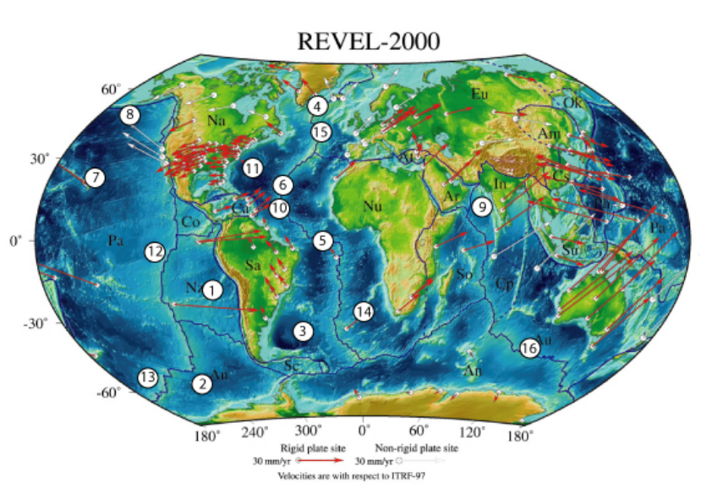

Figure 7 Shows the distribution of existing GPS sites that determine the present-day motion of the Earth’s tectonic plates. Proposed locations are shown as numbered in Table 1. Map is adapted from Sella et al., 2002.

Vast regions of the Earth’s surface, however, currently lack subaerial exposures for geodetic stations. The proposed buoy sites will provide platforms for GPS and acoustic measurements to measure the motion of the plate in these currently unoccupied regions [Spiess et al., 1998; Gagnon et al., 2005]. Typically, tracking at subaerial station requires decadal-long observation programs to precisely determine the plate motions at resolutions for rigidity tests. The long-term occupation of these sites envisioned as part of the observatory will provide a similar constancy of GPS-A time series data.
Transient plate motions are also of interest. High-rate GPS tracking has been used to observe the propagation of an earthquake deformation pulse at land GPS sites [Larson et al., 2003]. The global buoys provide high-sampling rate and real-time access to GPS-A data to capture these transient events. Additionally, the slow relaxation due to viscoelastic response of the oceanic athenosphere to subduction thrust events has been proposed as a physical process that affects the oceanic plates [Pollitz et al., 1998]. It has been suggested that the increase in local strain can trigger regional seismic activity. The most direct test to detect this phenomenon is measuring the motion of the oceanic plate seaward of a subduction zone.

In all, a number of unique scientific objectives can only be addressed with the long-term, continuous real-time access that ocean observatories will provide.

What are the motions and rigidity of tectonic plates?
The Pacific plate is the largest of the Earth’s tectonic plates. It is predominately an oceanic plate and void of any subaerial exposures over vast regions. Its present day motion has been determined from a dozen GPS sites tracked over an 11-year span [Beavan et al., 2002]. These sites, however, are mostly concentrated in the southwestern portion of the plate with vast unoccupied regions in the eastern half and with no sites north of the Hawaiian Islands. The proposed sites #7, 8, 12, and 13 will significantly improve determination of Pacific plate motion and tests of plate rigidity.
The Nazca plate has only two island stations for tracking its present-day motion. With these two stations there has been some variability in the determination of the present day Euler pole [Norabuena et al., 1999]. The proposed site #1 will occupy the southwestern region of the plate. It will strengthen the geometric distribution of velocities used to determine the rigid plate motion. Site #1 will also increase the redundancy of the rigid plate motion determination. This will permit the first tests of rigidity of the Nazca plate. Even though the North American, South American and Nubian plates have major continental exposures, they contain large expanses of oceanic plate. For example, the eastern halves of the North American and South American plates and the western half of the Nubian plate are oceanic regions largely lacking subaerial exposures. Sites #3, 4, 5, 6, 10, 11, 14 and 15 will improve Euler pole determinations and tests for plate rigidity. Site 10 will provide monitoring at a triple junction [Escartin et al., 2003].

What are the elastic and viscoelastic response of oceanic plate to faulting events?
Large subduction thrust events have been proposed as causing a diffusion pulse that propagates through the oceanic plate. The time-space distribution of deformation is a function of the perturbing thrust event and the viscosity of the oceanic asthenosphere. Sites #1, 2 and 8 are all located seaward of active subduction zones. These are in a position to observe both the co-seismic elastic response and the viscoelastic response of the oceanic plate to subduction thrust events. These types of measurements could provide an independent means to determine the viscosity of the oceanic asthenosphere.
On land, several geodetic techniques are combined to reveal characteristics of the Earth’s interior. While GPS dominates the subaerial geodetic landscape, other techniques (linear and volumetric strain, leveling, gravity, and tilt) offer solutions for various scale lengths and resolutions. Similarly, marine geodesy is mainly done with acoustics, but several other methods are available and useful. These include gravity, laser strain, tilt, and pressure. The ORION network of geophysical observatories provides a unique opportunity to sample these geodetic parameters in parts of the globe heretofore unobserved.

6. Site Descriptions
Nine of the eleven proposed ORION interdisciplinary global sites are of great interest for studies of Earth structure and geodynamics, geomagnetism and plate tectonics (shown by  in Table 1). The two remaining sites (the Irminger Sea site off East Greenland and the BATS site near Bermuda, respectively) are of lower priority because of their proximity to existing land-based geophysical stations. However, even at these sites installation of a hydrophone for T-phase and acoustics studies would be valuable.
The following is a brief summary of the geophysical interest in these sites, and the suite of geophysical instrumentation we are proposing for these sites (see Table 3). A plot of these sites on a global bathymetric map is shown in Figure 8.

Site 1 (18°S; 85°W Peru Basin. This site, located in central Nazca plate, was an Ocean Seismic Network (OSN) Phase 2 priority site for installation of a borehole geophysical observatory although it was not drilled by ODP. This site, together with three other proposed Pacific sites (sites 2, 12, 13) will significantly improve imaging of mantle plumes in the mid and lower mantle beneath the South Pacific “superswell” region from earthquake sources in the Tonga-Kermadec region. This site is also ideally located to detect and study deep water propagation of tsunami generated by earthquakes along the South American subduction zones. The Nazca plate is a totally oceanic plate with only two island stations for tracking its present-day motion. Geodetic measurements at this site will improve the geometric distribution of velocities needed to determine its rigid plate motion and will permit the first tests of the rigidity of the Nazca plate. This site is a high priority for a borehole geophysical observatory with a full suite acoustic, seismic, geomagnetic and geodetic instrumentation with a high-bandwidth, power-generating buoy with EOM cable to a seafloor junction box.

Site 2 (55°S; 90°W) Southeast Pacific; Site 13 (55°S; 150°W) Southwest Pacific: Site 16 (45°S; 99°E) Southeast Indian Ridge. The southern Pacific and Indian Oceans represent the largest existing gap in global geophysical coverage. These three sites would represent the first three Southern Ocean seafloor geophysical observatories. Geophysical observations at these sites will significantly improve imaging of lower mantle structure in the southern hemisphere (see Fig. 4), provide improved constraints on the structure of the Earth’s core and the origin of its magnetic field, and provide measurements of Antarctic plate motion and rigidity. Site 13 is located on west flank of the Pacific-Antarctic Ridge near the Udintsev fracture zone; Site 16 is on the remote Southeast Indian Ridge. Site 13 is proposed for a borehole geophysical observatory with a full suite acoustic, seismic, geomagnetic and geodetic instrumentation with a high-bandwidth, power generating buoy with EOM cable to a seafloor junction box.

Site 3 (42°S; 42°W) Brazil Basin; Site 14 (28°S; 2°E) Walvis Ridge: These sites, both proposed ION sites, would improve the global geophysical coverage in a region where there are few island stations. These two sites, along with sites 5 and 10, will improve imaging of the Farallon plate in the mid-mantle beneath South America and thus address fundamental questions regarding the fate of subducted slabs in the mantle. These sites will also improve Euler pole determinations and provide tests for plate rigidity for both the South American and Nubian plates. The high electrical conductivity of the outer core implies that the diffusion of magnetic field lines should be negligible (“frozen flux”) on timescales up to centuries. Almost all analysis of geomagnetic secular variation is based on this tenet. However, there are indications of an increase in flux beneath the South Atlantic in the late 20th century [Bloxham & Gubbins, 1986]. The evidence for this increased flux is tenuous, however, because of poor data coverage. Data from these two sites will be important in testing this “frozen flux” hypothesis.

Site 4 (60°N; 39°W) East Greenland; Site 11 (32°N; 64°W) BATS: Although a high-priority for studies of ocean circulation, climate and biogeochemistry, these sites are a lower priority for geophysical studies because of their proximity to Greenland and Bermuda respectively. We are proposing both sites be equipped with a broadband hydrophone for T-phase studies of earth-quake activity along the Mid-Atlantic. A bottom pressure sensor should also be installed at Site 11 for tsunami detection from events in the Puerto Rico trench or eastern Atlantic (Canary Is.).

Site 5 (0°S; 23°W) Equatorial Atlantic; Site 10 (15°N; 51°W) NTAS; Site 6 (23°N; 44°W) ODP 396B: The central Atlantic Ocean between 30°N and 30°S is the optimum location on the planet to record compressional-wave phases that interact with the Earth’s outer core and thus to study the structure of the core-mantle boundary (Fig. 5). These sites are ideally situated for these CMB studies. The modeled rate and paths of geomagnetic field reversals, as well as core-mantle coupling are affected dramatically by imposing different patterns of temperature variations on the CMB. This site is located in poorly sampled area where seismic and magnetic variations data will lead to substantial improvements in understanding core-mantle boundary temperature variability. This will also play an important role in increasing the spatial resolving power of geomagnetic methods by increasing the spherical harmonic degree and order of internal and induced geomagnetic field models.
Site 5 is located near some of Earth’s longest oceanic transform faults and largest oceanic transform earthquakes. Surface wave and body wave data from a seismic station here will enable the estimation of earthquake depth, seismic moment, and focal mechanism down to approximately M_{w} 4, greatly expanding our information on the distribution and timing of these earthquakes over a broad spectrum of sizes. This information can be used to test a basic hypotheses about earthquake physics, namely that all earthquakes, regardless of their eventual size, nucleate in the same way such that there is no inherent physical difference between foreshocks, mainshocks, and aftershocks. T-phase hydrophone at these sites, in conjunction with the existing hydrophone array at Ascension Island operated by the Air Force Technical Application Center and in the central Atlantic, will allow the location of events with magnitudes as low as ~2 over a large area of the central Atlantic.
Both sites 5 and 6 are proposed for borehole geophysical observatories with a full suite acoustic, seismic, geomagnetic and geodetic instrumentation with a high-bandwidth, power generating buoy with EOM cable. Site 6 is located at ODP 396B which was drilled on Leg 46 and is the highest priority ION site in the North Atlantic.

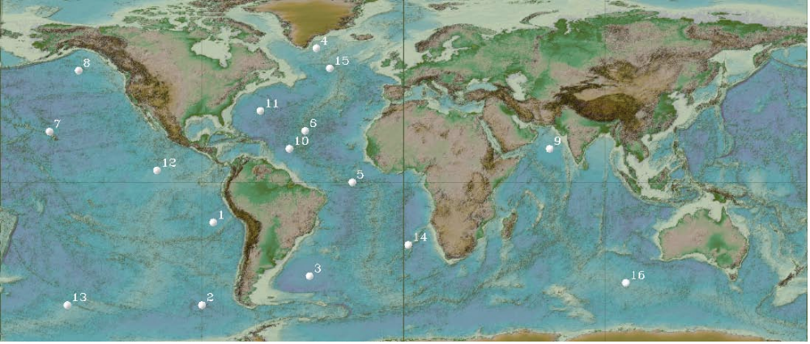
Figure 8. Bathymetric map of the world’s oceans showing the location of the proposed ORION global sites.

Site 7 (22.7°N, 158°W) HOT; Site 8 (50°N, 145°W) Gulf of Alaska; Site 12 (5°18’N; 110°6’W) ODP 1243: These three proposed North Pacific sites will complement three Japanese run seafloor geophysical observatories in the western Pacific (WP1 in the Philippine Sea; WP2 in the Northwest Pacific; JT2 in the Japan Trench), as well as H2O a cabled seafloor geophysical observatory lying between Hawaii and California. These sites will enable improved upper mantle and plume imaging in the Pacific, enable “pure-path” regional surface wave studies of lithospheric aging, upper mantle anisotropy and small-scale convection, and refine models of Pacific plate absolute plate motions. These sites are also ideally situated for T-phase studies of Pacific basin seismicity and tsunami propagation.
On the decadal scale, the flow of liquid iron at the CMB inferred from geomagnetic variations demonstrates such length-of-day variations may be due primarily to the exchange of angular momentum between the mantle and core (e.g. Holme & Whaler, 2001). There is evidence however that sea level changes and redistribution of ice sheets related to climate change may also produce a detectable decadal-scale variation in the length-of-day. The significant improvements in models of sub-annual-to-decadal scale fluid flow at the CMB expected from analysis of global geomagnetic observatory data augmented by data from site 8 opens up the possibility of testing this hypothesis, and of obtaining new and independent estimates of higher frequency contemporary and paleo-sea level changes.
A shallow borehole was drilled at Site 12 on ODP Leg 203 (ODP 1243) and this site is proposed for a borehole geophysical observatory with a full suite acoustic, seismic, geomagnetic and geodetic instrumentation with a high-bandwidth, power generating buoy with EOM cable.

Site 15 (51°N; 33°W) North Atlantic and Site 9 (15°N; 65°E) Arabian Sea: Site 15, located in the northern North Atlantic near the Charlie-Gibbs fracture zone, is a proposed ION site filling an important gap in global geophysical coverage in the North Atlantic between Iceland, Azores, UK and North America. A seafloor geophysical observatory here will provide improved upper mantle and plume imaging in the North Atlantic from regional surface wave studies, as well as an opportunity to study fracture zone fault mechanics on one of the Mid-Atlantic Ridge’s largest fracture zones. Site 9, located just north of a proposed ION site will fill a major gap in geomagnetic field coverage in this region.

7. Instrumentation Requirements
Many of the proposed sites will serve a multidisciplinary set of science objectives including air-sea flux studies, biogeochemistry and ecosystem dynamics investigations, and ocean circulation/climate research. As a result each global mooring site will be equipped with an appropriately diverse suite of instrumentation. In this proposal we only describe the geophysical instrumentation that will be installed at these proposed global sites – the instrumental requirement for other disciplines will be described in companion proposals. The proposed geophysical instrumentation, summarized in Table A-2 in the Appendix and described below, includes instruments for conducting acoustic, seismic, geomagnetic and geodetic research.

7.1 Acoustic and Seismic Instrumentation
Significant progress has been made in the past few years in addressing the technical problems associated with the deployment and recording of observatory-quality seismic stations on the seafloor. The 1998 OSN Pilot Experiment, carried out by the Scripps Institution of Oceanography and the Woods Hole Oceanographic Institution at the OSN-1 drill site (ODP Hole 843B) 225km southwest of Oahu, demonstrated the technical feasibility of deploying seafloor and buried broadband seismometers (BBOBS) and a borehole broadband instrument using wireline reentry and ROV technology [Collins et al., 2001; Stephen et al., 2005].
All three of the broadband instruments recorded data continuously and autonomously on the seafloor from the time they were deployed in early February until late May or early June (at least 115 days). Over fifty teleseismic earthquakes were observed on the broadband systems ranging from a 4.5Mb event at 44° epicentral distance (2/14/98 2:15:03) to the 8.0Mw Balleny Islands earthquake at 91° epicentral distance (3/25/98 3:12:26). Signal to noise ratios for earthquakes varied depending on frequency band, ambient noise conditions, and sensor design. Analysis indicates that the seafloor borehole broadband seismic installation provided comparable- to superior-quality data in comparison with similar continental and island stations over the band from 0.003 to 5Hz (Fig. 9).
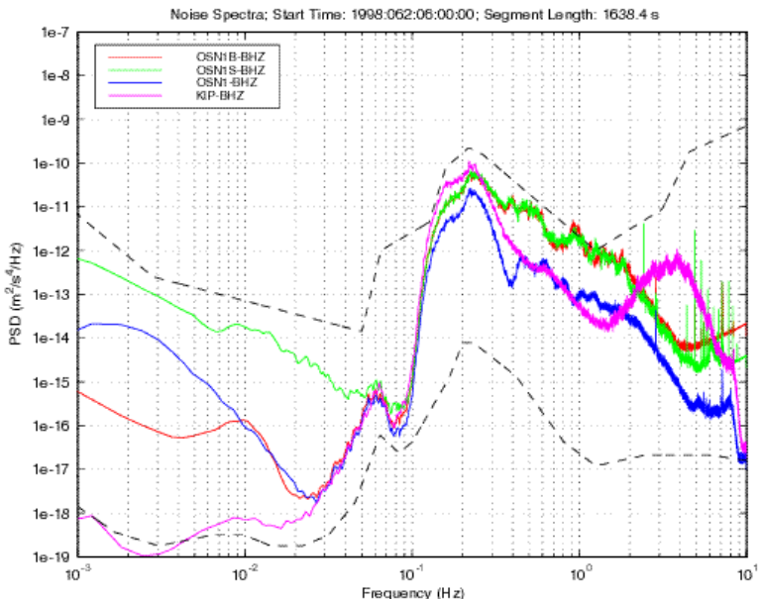
The shallow buried broadband system compared very favorably with the borehole system for signals in the frequency band from 0.01 to 0.07Hz. However, within the microseism band (0.1-5 Hz), the background noise levels recorded by the borehole seismograph are substantially less than the levels on the buried BBOBS. The higher noise levels on either BBOBS are probably a result of scattering of microseism energy by the seafloor and sediment-basement topography into short- wavelength shear modes. This difference in background noise levels means that the detection threshold for short-period body waves is significantly lower for the borehole seismograph than for the BBOBS. Within the microseism band, the background noise levels of the seafloor and buried BBOBS are similar.
However, at frequencies less than ~0.1 Hz, the seafloor BBOBS is 20-40 dB noisier than the buried BBOBS. The high background noise levels of the seafloor BBOBS appear to be due to ocean-bottom currents pushing on the seismometer and the seafloor, generating tilt-induced accelerations. At frequencies below 10 mHz, the noise level of the borehole instrument rises and the buried BBOBS is the quietest instrument. While the origin of this noise is not understood, it likely results from the installation of the sonde in a water-filled hole and associated water motion and convection.
Figure 9. Vertical component power spectra for the borehole, BBOBS and Kipapa, Hawaii stations. The seafloor buried and borehole sensors provide comparable quality data to land stations over a frequency band of 0.003 to 5Hz.
The OSN Pilot Experiment demonstrated that seafloor broadband seismic stations with performance comparable or superior to nearby island stations are now feasible. The permanent stations will ideally be located in shallow boreholes to reduce noise levels near and above the microseism peak, although if a borehole is not available high-quality data can be obtained, especially below 0.1Hz, with a sensor buried at shallow depths in sediment.
The acoustic and seismic instrumentation we are proposing to install at the ORION interdisciplinary global moorings for Earth structure and geodynamic studies include two broadband hydrophones (one located in the Sofar channel and one on a seafloor OBS), a seafloor pressure sensor (for tsunami detection and research), and an OBS with a sediment-buried broadband seismometer, differential pressure gauge, and optional strong motion accelerometer at selected sites (see Table A-2). While in the longer term it would be desirable to have seismometers installed in a shallow borehole at each of these sites, we are proposing just five borehole installations (sites 1,5,6,12, 13). At two sites (6, 12) boreholes suitable installation of a broadband seismometer and borehole strainmeter already exist; at the three other sites holes would have to be drilled in collaboration with IODP. At the non-borehole sites a broadband OBS with a buried sensor would be used in place of a borehole installation.

7.2 Geomagnetic Instrumentation
Planning and implementation of real-time seafloor EM observatories commenced in earnest about fifteen years ago, e.g. Chave et al [1990], with activity in Japan and in the US aimed at taking over decommissioned submarine cables for passive electric field measurements (e.g. Lizarralde et al, 1995) for the first scientific use of trans-oceanic cables. Ideally, a complete seafloor observatory monitors both electric and magnetic fields, enabling both shallow and deep-mantle EM imaging, and also permitting measurement of barotropic ocean currents, as well as secular variation studies of the geomagnetic field. A notional engineering design for a seafloor magnetic observatory was first published in an NSF-funded workshop report [Chave, et al, 1995], and a small number of prototype systems have been developed in Japan (H. Toh, 1998) and France (P. Tarits, pers comm).
The technical drivers for the geoelectromagnetic observatory instrumentation are the requirement to obtain stable, absolute baseline values of the geomagnetic field, and to decompose the values into three orthogonal vector components. At a minimum, a scalar baseline value may be obtained at low sample rates, and vector variations about that baseline measured at higher sample rates. These values are references to absolute geodetic coordinates, ultimately to be expressed as magnetic intensity, inclination and declination relative to true north and true vertical. INTERMAGNET standards for terrestrial geomagnetic observatories provide the design goal, with absolute field declinations established to 6 arc-seconds accuracy. The INTERMAGNET standard of 1 Hz sampling is not required for deep ocean locations, since such high frequency external magnetic field variations are shielded from the deep seafloor by the electrically conductive seawater overburden. It is technically reasonable to record 1 minute mean values, particularly at the shallower water depth sites, and there is little reason to standardize on slower sampling rates since both sensors and observatory bandwidth can accommodate these data rates easily.
The field components are to be established to 10 pT/Hz⁻², with geodetic orientation established as closely as possible to the INTERMAGNET ideal, although at present it is technically difficult (using compact geodetic sensors) to achieve much better than ~3.4 arc-mins per each individual 180 s integration cycle. Repeat measurements over multiple integration cycles can reduce this to sub arc-min levels. The basic data stream will therefore consist of three vector magnetic field components, each samples at 24-bits, absolute baseline measurements, two or three vector geoelectric components, and engineering data. There has been a recent set of improvements in long-period geomagnetic instrumentation, now making it possible to obtain absolute vector magnetic field data from a single compact package. This package makes use of Overhauser technology to establish the absolute baseline values of the geomagnetic field to 10 pT/Hz^{–2} over 5-sec integration periods. Spherical coils surrounding the optically-pumped magnetometer housing are used to buck out the individual vector field components. This is known as the suspended dIdD configuration (www.gemsys.ca). The observatory would also include an electrometer with three orthogonal electric dipole receivers, temperature sensors, a geodetic north-seeking gyroscope to orient the sensor in the geodetic frame and for determination of absolute magnetic inclination and declination, a stable non-ferric platform anchored rigidly to the seafloor, and a network interface with TCP-IP communications. The geoelectromagnetic sites will be collocated with seismic and oceanographic observatory locations, although a stand-off of tens of meters to one km may be required to prevent pickup of EM signal sources from these other sensors.

7.3 Geodetic Instrumentation
Several different types of seafloor geodetic instrumentation are envisioned at the geophysical global sites (see Table A-2 in Appendix). The simplest instrument is a precise pressure gauge. It can provide mm–scale information on changes in the vertical component of a seafloor reference point [Chadwick et al., in press, 2005] (acoustics have difficulty with the vertical coordinate because of the unpredictability of sound speed with depth). Pressure gauges drift and will not be useful for secular signals, but can reveal rapid episodes of uplift or subsidence.
The GPS-Acoustic (GPSA) approach extends GPS positioning for crustal motion studies to the seafloor. It combines GPS with acoustic ranging to measure the position of seafloor transponders with centimeter-level resolution in the same global reference frame as land-based GPS sites [Spiess et al., 1998, Gagnon et al., 2005]. The seafloor array can be 100s of km from shore allowing geodetic measurements of plate motion across the seafloor/continental interface or between widely separated seafloor points.
Relative gravity meters are similarly useful for observing vertical episodic deformations and, when used in conjunction with pressure data, can reveal the mechanism responsible for the deformation. Continuously recorded gravity meters double as very good long-period seismometers. The joint observation of pressure fluctuations (from long wavelength ocean waves) and gravity changes, caused by ground accelerations in response to varying load from the ocean, can reveal mechanical characteristics of the local crust (i.e. the “compliance”) (Crawford et al., 1991). This is also observable also with strainmeters. These geodetic tools can measure the response of Earth to known driving forces – the tides at long periods and ocean waves at shorter periods.
One unique opportunity in the ORION system will arise when an observatory is sited adjacent to a borehole. Fiber optic strain sensors [Zumberge and Wyatt, 1988] installed in such boreholes at varying depths recording strain tides have the potential to reveal vertical variations in rheological properties of the ocean crust in a manner independent from the assumptions applied to seismic investigations. Such observations have proven fruitful on land [Agnew, 1979) but have not been possible in the ocean (although one attempt is underway [Sacks et al., 2000]).

7.4 Power/Telemetry Requirements
The power and data telemetry requirements of the geophysical instruments proposed for these global sites are summarized in Table A-3 in the Appendix. Power requirements vary widely from less than a W (for a simple hydrophone or pressure sensor) to >20 W (for a fiber optic strain meter or gravity meter). With the exception of the strain meter and gravimeter, the power requirements of the other instruments can be provided by battery packs with servicing intervals of 1-3 years. If power can be generated on the buoy and delivered via an EOM cable to a seafloor junction box, less than 70W would be required to operate all of the proposed instruments.
Data acquisition rates also vary widely ranging from tens of Mbytes/day for a strainmeter, seismometer or hydrophone to only 4 Kbytes/day for a magnetometer. Although acoustic and seismic data rates are high, most of these data are not of immediate interest. If only events of interest are transmitted to shore, telemetry requirements can be substantially reduced. For example, The Harvard CMT catalog (http://www.seismology.harvard.edu/CMTsearch.html) for the 10 year period 1991-2000 lists 2,246 events with (i) M_{s} ≥ 5.0, depth ≤ 33 km, and Δ ≤ 90° and (ii) M_{s} ≥ 5.5, depth ≤ 33 km, and 90° < Δ ≤ 180°. Assume, optimistically, that all of these events generate high-quality surface waves, and that 1 hour of data, on average, is sufficient for analysis of each. The telemetry load for one year of surface wave data is then only 9 Mbytes. This number is for 4 data channels (3 seismometer channels and 1 pressure channel), sampled at 1 Hz, and assuming a compression factor of 2. The CMT catalog for the same 10 year period lists 1,901 events with (i) m_{b} ≥ 5.0, depth > 33 km, and Δ <= 90°, and (ii) m_{b} ≥ 5.5, depth > 33 km, and 90° < Δ ≤ 180°. Assume, optimistically, that all of these events generate detectable P and S body waves, and that, on average, 0.5 hours of data is sufficient for analysis. The telemetry load for one year of body wave data is only ~39 Mbytes. This number is for 3-component seismometer data sampled at 20 Hz, and assuming a compression factor of 2. The total annual telemetry load is then < 50 Mbytes, which can be transmitted over an Iridium link in about two days without allowing for error correction. On the basis of event times published in the global earthquake catalog (updated daily), appropriate portions of the data set can be telemetered ashore for directed study in near-real-time. The full dataset can be retrieved during an annual servicing visit to the node. Data rates for geomagnetic and geodetic data are low and can easily be accommodated by an acoustically-linked system.
We are proposing that the 5 borehole sites be equipped with a high-end buoy that can deliver up to 100W of power to a seafloor junction box and that can telemeter >500 Mbyte of data to shore daily. However, for the other 11 proposed sites we believe an acoustically-linked mooring can meet the telemetry requirements of geophysical instruments which we are proposing to install at these sites. In May 2004, an acoustically-linked, moored buoy observatory system was deployed in 2,372 m deep water off Vancouver Island in order to monitor fluid expulsion along the Nootka fault where the fault crosses the accretionary prism [Frye et al., 2004]. This system, deployed in a challenging environment, is still operating, and over an ~10 month period, has delivered ~150 Mbytes from the buoy to shore over an Iridium link, 115 Mbytes of which were acoustically telemetered from the seafloor.

7.5 Installation and Servicing Requirements
Table A-4 summarizes the installation and servicing requirements for the geophysical instrumentation being proposed for the global sites, including required ship and ROV time for installation and servicing. In all cases, the requirements are relatively modest, ~10 days/site of ship/ROV time for installation (depending on the instrument suite installed at the site, and ~4 days/site of ship/ROV time each year for annual servicing and maintenance.
For autonomously-powered instrumentation deployed at acoustically-linked observatories, the use of an ROV permits battery packs to be replaced without the need to disturb buried seismometers and carefully leveled and oriented magnetometers. This ensures not only consistent data quality but also greatly reduces the risk of damage to the sensors. By separating the data logger from the sensor, thereby allowing the former to be recovered during annual servicing and maintenance, the complete data set acquired by each instrument will be retrieved annually. A technician or junior engineer will probably be adequate technical support for this mode of operation.

8. Program Management
Seismic Seismic, hydroacoustic, and bottom pressure data acquisition will be the joint responsibility of WHOI and SIO. Together, WHOI and SIO will select and build the instrumentation appropriate to each site. Most of the individual instrument components (e.g. broadband seismometer, data logger, pressure sensor) are available commercially. However, broadband ocean bottom or borehole seismographs are not available commercially. Fortunately, both institutions have years of experience designing and building these systems. More importantly, seismologists and engineers from both institutions have a track record of successful collaboration on instrument development and deployment. WHOI and SIO will together provide the engineering and technical support required for annual maintenance of the seismic systems at these global sites.

Geomagnetic The geomagnetic portion of this project will be overseen by Adam Schultz (OSU), and will involve colleagues at several other institutions including WHOI, ??. Monthly teleconferences will be held to track progress, supplementing electronic communications. In-person meetings will be held during pre-deployment period, and annually post-deployment. During the initial period, site survey data will be analyzed to determine exact location of the EM sensor platforms in relation to other instruments approved separately by ORION. Close consultation is required with ORION engineers, particularly with regard to minimizing EM interactions between our sensors and other system components. This imposes a requirement for test deployments at the MARS testbed as an integral part of site planning –the results of these tests may dictate the stand-off required between the instruments and ORION buoy science interface nodes.
Only GEM Systems (Ontario, Canada) appears to make the integrated package that meets our requirements without a large degree of engineering required at our end. The design and construction of the electric dipole receiver array can be completed either commerically, or by a participating university lab, and then integrated into an ORION-approved TCP-IP enabled seafloor data control system. A rotating, gimbal-mounted platform is required inside each magnetometer pressure housing. This aligns the magnetometer to true north, and holds it horizontal. This will require adaption of a servo control system already developed by various university labs, and implementation of a non-magnetic motor drive. Magnetometer calibration can provided by the GSC Geomagnetism lab. This project will benefit from the existence of a modular network-capable instrumentation platform (data logger/controller, network interface) in an advanced state of development at OSU – now being configured for operations at the MARS testbed.

Geodetic Chadwell and Zumberge (SIO) will coordinate management of the geodetic sensors in the global buoy array. This will involve transition of existing instrumentation to specifics of the buoy infrastructure. These systems are proven technologies. The GPS-A system has been operated from buoys for experiments lasting a few days. Once deployed they will oversee heath status and quality control.

9. Data Management and Distribution
The net amount of data telemetered ashore from all 16 stations depends strongly on the mix of high-end and low-end buoys stations. A mix of 5 high-end and 11 low-end buoys will result in a telemetry load of, <100 Mbytes/day. Continuous data streams from sensors connected to the 5 high-end buoys will flow ashore in real-time with little shore-side science input. For the acoustically-linked observatories, all of the low rate data from geomagnetic and geodetic sensors will be automatically telemetered ashore. However, for high sample rate seismic and acoustic data the acoustically-linked observatories will need to be explicitly “pulled” ashore. This process may be partially automated whereby on the basis of events times published in the global earthquake catalog (updated daily), the 1 Hz, 20 Hz or 40 Hz seismic data streams are requested for all events above a given magnitude. Alternatively, a shore-side operator will identify and request time series from specific data channels on the basis of (say) event tables previously uploaded from the seafloor.
All the geophysical data collected at these global sites will be freely and immediately available to any interested investigator. The models we have in mind are the USArray and Plate Boundary Observatory (PBO) components of EarthScope, and the IRIS Global Seismic Network (GSN) and DMS (Data Management System) programs. The data reduction and management tasks for the seismic data are similar to those faced by the USArray. The real-time data acquired with the 200 USArray seismographs flows through the Array Network Facility (ANF) at IGPP-UCSD. (The IRIS DMC also receives a separate feed of the “raw” data). The ANF monitors station performance and” up-time”, performs quality control on the incoming data, adds the appropriate metadata (seismometer transfer function, orientations, station coordinates), reformats the data into SEED, and sends the SEED volumes to the IRIS DMC. As part of the QC process, the ANF measures P and S arrival times and performs preliminary event locations. A similar capability will be required for the seismic data acquired at the global buoy observatories, and will be the responsibility of WHOI and SIO.
We do not presently know how the ORION management system will be structured but we would anticipate archiving and distributing all seismic and geomagnetic data collected at these sites through the IRIS DMC. Integration of GPS geodetic data into the UNAVCO archive is anticipated. Data will be made available on-line through the ORION data management system.
Geomagnetic data QC will be the responsibility of OSU. Tasks will include continuous monitoring of system performance, streaming to data servers, and routine QC procedures for generation of archivable data sets. It is envisaged that a request for tender would be issued to identify a vendor for production of (semi)automated geoelectromagnetic data QC software, following the model used by the NSF EarthScope USArray program. As in USArray, geoelectromagnetic data would conform to SEED format, and flow into the IRIS DMC for distribution through a data portal developed under that program.
All geodetic data will be processed at SIO to provide position of buoy with GPS, position and velocity of seafloor sites. Additional products from the GPS include measurements of atmospheric phenomena, specifically the integrated measure of precipitable water in the troposphere and the Total Electron Content (TEC) of the ionosphere.
10. References:
Agnew, D.C., Strain tides at Pinon Flat: analysis and interpretation. University of California, San Diego. (Ph. D. in Earth Sciences), 1979.
Albarède, F. and R. van der Hilst, Zoned mantle convection,Phil. Trans. R. S. MPES, 360, 2569-2592, 2002.
Anderson, D.L., Top down tectonics?, Science, 293, 2016-2018, 2001.
Baba, K., N. Seama, T. Goto, M. Ichiki, K. Schwalenberg, K. Suyehiro, & H. Utada, 'Electrical transection of the upper mantle in the Mariana subduction system'. 17th workshop on EM induction in the Earth, Hyderabad, India, Oct. 18-23, 2004.
Beavan, J., P. Tregoning, M. Bevis, T. Kato, C. Meertens, The motion and rigidity of the Pacific plate and implications for plate boundary deformation, J. Geophys. Res., 107(B10), 2261, doi:10.1029/2001JB000282, 2002.
Bréger, L., H. Tkalcic, and B. Romanowicz, The effect of D" on PKP(AB-DF) travel time residuals and possible implications for inner core structure, Earth and Planetary Science Letters, 175, 133-143, 2000.
Chadwick, W.W., Jr., S. Nooner, M. Zumberge, R.W. Embley, and C.G. Fox, Vertical deformation monitoring at Axial Seamount since its 1998 eruption using deep-sea pressure sensors, J. Volcanol. Geotherm. Res., in press.
Chave, A.D., Butler, R., Pyle, T.E. (Eds.). Workshop on Scientific Uses of Undersea Cables. Washington, D.C. (Joint Oceanographic Institutions), 1990.
Chave, A., A.W. Green, R.L. Evans, J.H. Filloux, L.K.Law, R.A. Pettit, J.L. Rasson, A. Schultz, F.N. Spiess, P. Tarits, M. Tivey & S.C. Webb, Report of a Workshop on Technical Approaches to Construction of a Seafloor Geomagnetic Observatory, WHOI Technical Report WHOI-95-12, 1995.
Clark, H.L., New seafloor observatory networks in support of ocean science research, National Science Foundation IEEE Conference Publishing 445 Hoes Lane Piscataway, NJ 08855-1331, 2003.
Crawford, W.C., Webb, S.C., Hildebrand, J,A., Seafloor compliance observed by long-period pressure and displacement measurements, J. of Geophys. Res., Vol. 96, Issue B10, p. 16151-16160, 1991.
Creager, K.C., Large-scale variations in inner core anisotropy, Journal of Geophysical Research, 104, 23,127-23,172, 1999.
DeMets, C., R. G. Gordon, D. F. Argus, and S. Stein, Effect of recent revisions to the geomagnetic reversal time scale on estimates of current plate motions, Geophys. Res. Lett., 21(20), 2191-2194, 1994.
DEOS Global Working Group Report, Moored Buoy Ocean Observatories, National Science Foundation, Arlington, Virginia, 1999.
Edwards, R.N. & K. Schwalenberg, Distortion of sea floor electromagnetic fields by topography, Proceedings of the Fourth Workshop on Marine Electromagnetics (MARALEC), London, March 2004
Ekström, G., and A.M. Dziewonski, The unique anisotropy of the Pacific upper mantle, Nature, 394, 168-172, 1998.
Escartin, J., D. K. Smith, M. Cannat, Parallel bands of seismicity at the Mid-Atlantic Ridge, 12–14_N, Geophys. Res. Lett., 30(12), 1620, doi:10.1029/2003GL017226, 2003
Evans, R. L., P. Tarits, A. D. Chave, A. White, G. Heinson, J. H. Filloux, H. Toh, N. Seama, H. Utada, J. R. Booker, & M. J. Unsworth, Asymmetric electrical structure in the mantle beneath the East Pacific Rise at 17°S'. Science 286, 752-756, 1999.
Evans, R.L., Webb, S.C., and the RIFT-UMC Team: Crustal resistivity structure at 9°50'N' on the East Pacific Rise: Results of an electromagnetic survey. Geophys. Res. Lett. 29(6). doi:10.1029/2001GL014106, 2002.
Fujii, I & A, Schultz, The three-dimensional electromagnetic response of the Earth to ring current and auroral oval excitation, Geophys. J. Intl, 151 (3): 689-709, 2002.
Gagnon, K., C. D. Chadwell, E. Norabuena, Measuring the onset of locking in the Peru-Chile trench with GPS and acoustic measurements, Nature, 434, pp. 205-208, 2005
Grand, S., R. van der Hilst and S. Widiyantoro, Global seismic tomography: a snapshot of convection in the Earth, GSA Today, 7, 4, 1-7, 1997.
Jegen M. & Edwards R.N., The Electrical Properties of a 2D Conductive Zone underneath the Juan de Fuca Ridge. Geophys. Res. Lett., 25, 3647-3651., 1998.
Kellogg, L.H., B.H. Hager, R.D. van der Hilst, Compositional stratification in the deep mantle, Science, 283, 1881-1884, 1999.
Key, K. & S. Constable, Broadband marine MT exploration of the East Pacific Rise at 9°50'N. Geophys. Res. Lett. 29(22). doi:10.1029/2002GL016035, 2002.
Kuvshinov, A, H Utada, D Avdeev & T Koyama. 3-D modeling and analysis of Dst C-responses in the North Pacific Ocean region, revisited. Geophys. J. Intl., 160, 505-526, 2005.
Larsen, J.C. & T.B. Sanford, Florida Current volume transports from voltage measurements. Science, 227, 302-304, 1985.
Larson, K. M., P. Bodin, J. Gomberg, Using 1-Hz GPS Data to Measure Deformations Caused by the Denali Fault Earthquake, Science v. 300, pp. 1421-1424, 2003.
Lizarralde, D., A. Chave, G. Hirth, & A. Schultz. Long period magnetotelluric study using Hawaii-to-California submarine cable data: implications for mantle conductivity, J Geophys. Res., 100, No. B9, 17,873-17,854, 1995.
MacGregor, L., M. Sinha, & S. Constable, Electrical resistivity structure of the Valu Fa Ridge, Lau Basin, from marine controlled-source electromagnetic sounding. Geophys. J. Int. 146, 217-236, 2001. Montagner, J. P. Upper mantle low anisotropy channels below the Pacific Plate, Earth Planet. Sci. Lett., 202, 263-274, 2002.
Montagner, J.-P., and T. Tanimoto, Global upper mantle tomography of seismic velocities and anisotropy, Journal of Geophysical Research, 96, 20,337-20,351, 1991.
Morelli, A., A.M. Dziewonski, and J.H. Woodhouse, Anisotropy of the core inferred from PKIKP travel times,, Geophysical Research Letters, 13, 1545-1548, 1986.
Motobayashi, T., H. Toh, K. Baba & M. Ichiki, Two-dimensional electrical section beneath the backarc region of northeast Japan, Trans. Amer. Geophys. Union, AGU Fall Meeting, 2004.
National Research Council, Illuminating the Hidden Planet: The Future of Seafloor Observatory Science, Committee on Seafloor Observatories: Challenges and Opportunities, Ocean Studies Board, National Academy Press, 135 pp., 2000, http://www.nap.edu/books/0309070767/html/
National Research Council, Enabling Ocean Research in the 21st Century: Implementation of a Network of Ocean Observatories, Committee on the Implementation of a Seafloor Observatory Network for Oceanographic Research, National Academy Press, 240 pp., 2003.
Neal, S.L., R.L. Mackie, J.C. Larsen & A. Schultz. Variations in the electrical conductivity of the upper mantle beneath North America and the Pacific Ocean, J. Geophys. Res., 105, B4, 8229-8242, 2000.
Nishimura, C.E., and D.W. Forsyth, The anisotropic structure of the upper mantle in the Pacific, Geophysical Journal International, 96, 203-229, 1989.
Norabuena, E., Dixon, T. H., Stein, S. & Harrison, C. G. A. Decelerating Nazca–South America and Nazca–Pacific Plate motions. Geophys. Res. Lett. 26, 3405–3408, 1999.
Pollitz, F. F., R. Burgmann, B. Romanowicz, Viscosity of the Oceanic Asthenosphere Inferred from Remote Triggering of Earthquakes, Science v. 280, pp. 1245-1249, 1998.
RECONN Regional Cabled Observatory Network (of Networks), Report of the Cabled Regional Observatory Workshop, NSF report, 2003
Rost, S., and J. Revenaugh, Seismic detection of rigid zones at the top of the core, Science, 294, 1911-1914, 2001.
Sacks, L.S., Suyehiro, K., Acton, G.D., et al., 2000, Proceedings of the Ocean Drilling Program, Initial Reports Volume 186.
Schultz, A. & G. Pritchard. A three-dimensional inversion for large-scale structure in a spherical domain, in “Three-Dimensional Electromagnetics”, ed B. Spies and M. Oristigliano, SEG, Geophysical Developments Series, v. 7, 451-476, 1999.
Schultz, A., R.D. Kurtz, A.D. Chave, & A.G. Jones. Conductivity discontinuities in the upper mantle beneath a stable craton, Geophys. Res. Lett.,20, 2941-2944, 1993.
SCOTS: Scientific Cabled Observatories for Time Series, NSF, Arlington, Virginia, 2002.
Schwalenberg, K. & R.N. Edwards, 'The effect of sea floor topography: An analytic formulation for the magnetotelluric fields in the presence of a harmonic interface', Geophys J Int, in press, 2003.
Sella, G. F., T. H. Dixon, and A. Mao, REVEL: A model for Recent plate velocities from space geodesy, J. Geophys. Res., 107(B4), 1456, doi:10.1029/2000JB000033, 2002.
Spiess, F. N., C. D. Chadwell, J. A. Hildebrand, L. E. Young, J. G. H. Purcell, and H. Dragert, Precise GPS/Acoustic positioning of seafloor reference points for tectonic studies, Phys. of the Earth and Plan. Int., 108, 101-112, 1998.

THE NATIONAL GEOMAGNETIC INITIATIVE, U.S. Geodynamics Committee, Board on Earth Sciences and Resources, Commission on Geosciences, Environment, and Resources, National Research Council, NATIONAL ACADEMY PRESS, Washington, D.C., 1993.
Thorne, M., Garnero, E.J., and S. Grand, Geographic correlation between hot spots and deep mantle lateral shear-wave velocity gradients, Phys. Earth Planet. Int., 146, 47-63, 2004.
Toh, H., T. Goto, & Y. Hamano. A new seafloor electromagnetic station with an Overhauser magnetometer, a magnetotelluric variograph and an acoustic telemetry modem. Earth, Planets and Space 50, 895–903, 1998.
Tyler, Robert H., Josef B. Oberhuber & Thomas B. Sanford, The potential for using ocean generated electromagnetic fields to remotely sense ocean variability. Physics and Chemistry of the Earth, 24, 429-432, 1998.
Zumberge, M. A., and Wyatt, F. K., “Optical fiber interferometers for referencing surface benchmarks to depth.” Pure and Applied Geophysics, 152, (1988): 221-246.
Uyeshima, M. & A. Schultz. Geoelectromagnetic induction in a heterogeneous sphere: a new 3-D forward solver using a staggered-grid integral formulation, Geophys. J. Intl., 140, 636-650, 2000.
Velimsky, J & Z Martinec. Time-domain, spherical harmonic-finite element approach to transient three-dimensional geomagnetic induction in a spherical heterogeneous Earth, Geophy. J. Int., 161, 81-101, 2005.
Woodhouse, J.H., D. Giardini, and X.-D. Li, Evidence for inner core anisotropy from splitting in free oscillation data, Geophysical Research Letters, 13, 1549-1552, 1986.

APPENDICES

Table A-1 Ranked ORION Global Interdisciplinary Sites
 | LAT | LONG | GEOPHYS | AIR-SEA | PHYSO | BIOGEO | RANK
INTERDIS | 18S | 85W | 1 | 1 | 2 | 1 | 1.25
INTERDIS | 55S | 90W | 2 | 1 | 1 | 1 | 1.25
INTERDIS | 42S | 42W | 1 | 4 | 2 | 2 | 2.25
INTERDIS | 60N | 39W | 4 | 1 | 1 | 3 | 2.25
INTERDIS | 0 | 23W | 1 | 4 | 3 | 2 | 2.5
INTERDIS | 23N | 44W | 1 | 3 | 4 | 3 | 2.75
BIOGEO | 22.7N | 158W | 4 | 2 | 4 | 1 | 2.75
INTERDIS | 50N | 145W | 3 | 2 | 3 | 3 | 2.75
INTERDIS | 15N | 65E | 3 | 3 | 3 | 2 | 2.75
AIR-SEA | 15N | 51W | 4 | 1 | 2 | 4 | 2.75
PHYSO | 57N | 53W | 4 | 2 | 1 | 4 | 2.75
INTERDIS | 55S | 150W | 2 | 4 | 4 | 2 | 3
BIOGEO | 5S | 110W | 3 | 4 | 4 | 1 | 3
BIOGEO | 40N | 145W | 2 | 4 | 4 | 2 | 3
BIOGEO | 28S | 120W | 4 | 4 | 3 | 1 | 3
PHYSO | 32N | 65W | 4 | 2 | 2 | 4 | 3
GEOPHYS | 28S | 2E | 2 | 4 | 4 | 3 | 3.25
GEOPHYS | 5.3N | 110.1W | 1 | 4 | 4 | 4 | 3.25
AIR-SEA | 38.5N | 65W | 4 | 1 | 4 | 4 | 3.25
AGREED | 45N | 165E | 4 | 4 | 1 | 4 | 3.25
PHYSO | 40N | 70W | 4 | 4 | 1 | 4 | 3.25
GEOPHYS | 51N | 33W | 2 | 4 | 4 | 4 | 3.5
AIR-SEA | 0 | 156E | 4 | 2 | 4 | 4 | 3.5
BIOGEO | 0 | 155W | 4 | 3 | 4 | 3 | 3.5
PHYSO | 49N | 16.5W | 4 | 4 | 2 | 4 | 3.5
INTERDIS | 12N | 88E | 4 | 3 | 4 | 4 | 3.75
GEOPHYS | 37S | 150W | 3 | 4 | 4 | 4 | 3.75
GEOPHYS | 45S | 99E | 3 | 4 | 4 | 4 | 3.75
AIR-SEA | 0 | 55E | 4 | 3 | 4 | 4 | 3.75
PHYSO | 35N | 150E | 4 | 4 | 3 | 4 | 3.75

Ranking of 30 sites: 10 “interdisciplinary” sites and 5 “disciplinary” sites from each of four disciplinary groups: geophysics, air-sea interaction, physical oceanography, and biogeochemistry. Ranking by discipline group: 1 = a top 5 site for that discipline group ; 2 = next five, etc. Average ranking shown in column on the right. The sites highlighted in yellow received the highest interdisciplinary rankings. The sites highlighted in blue, were also ranked high priority for global geophysical studies.

Figure A-1 Plot of location of 30 sites listed in Table A-1

Table A-2 Proposed Geophysical Instrumentation for Global Sites
Instrument | Scientific  Objective | Number per site | Unit cost | Sites required
Broadband hydrophone with digitizer/data logger | T-phase detection; acoustic tomography | 1 | $5K | All sites
OBS with buried broadband seismometer, differential pressure gauge, hydrophone | Earth structure and tectonics | 1 | $80K | All sites except 4-6,11,13,15,16
OBS as above but with strong motion accelerometer | Earthquakes physics and rupture processes | 1 | $90K | Sites 5,6,13,16
Borehole broadband seismometer | Earth structure and tectonics | 1 | $260K | All borehole sites (1,5,6,12,13)
Digital pressure sensor with data logger | Tsunami detection; vertical deformation of seafloor | 1 | $20K | All sites except 4
3-component absolute vector suspended dIdD magnetometer, 3-comp. electrometer; geodetic N-seeking gyro; tilt sensor | Earth geomagnetism | 1 | $117K | All sites except 4,7,11
Dual-Channel GPS Receiver  High-Precision Acoustic Transponder | Plate motion vectors;  Episodic spreading;  Monitor propagating strain fronts  Atmos. water vapor | 3  4 | 3 x $15K  4 x $20K | All sites except 4,7,11
Interferometric Fiber-Optic Strainmeter with digitizer/data logger | Visco-elastic structure of oceanic lithosphere (tidal loading) | 1 | $50K | All borehole sites w/EOM cable (1,5,6,12,13)
Relative Gravity Meter | Vertical deformation; normal-mode seismology | 1 | $100K | All sites w/EOM cable

Table A-3 Geophysical Instrumentation: Power and Telemetry Requirements
Instrument | Power  (W) | Sample rate  (Hz) | Acquisition  rate (total)  (Mbytes/day) | Acquisition  rate (event)  (Mybtes/yr) | Timing  Accuracy  (ms)
Broadband hydrophone with digitizer/data logger | 0.2 | 100 (T-phase); | 18 | ~50 | 0.1
OBS with buried broadband seismometer, differential pressure gauge and hydrophone | 1.25 | 1;20;40 | 11;22 | <50 | 1.0
Borehole broadband seismometer | 10 | 1;20 | 11 | <50 | 1.0
Digital pressure sensor with data logger | 0.25 | 1 | 0.18 | NA | 1
3-component absolute vector suspended dIdD magnetometer, 3-comp. electrometer; geodetic N-seeking gyro; tilt sensor | 2^ | 0.2 (internally recorded)  .017 (telemeterd) | .025 | NA | 100#
Dual-Channel GPS Receiver | 5 | 3 x 1 Hz | 10 | NA | 0.00005  (will provide)
High-Precision Acoustic Transponder | 1 | 4 x 1/minute | 0.05 | NA | 0.001
Interferometric Fiber-Optic Strainmeter | 20* | 200 Hz | 36 | NA | 1
Relative Gravity Meter | 25* | 4 x 1 Hz  (g, T, θ_{x}; θ_{y}) | 0.7 | NA | 1
^ 23W when geodetic sensor powered; #30s timing accuracy require for 1 minute mean values telemetered to shore
* requires power generation on buoy and EOM cable to seafloor

Table A-4 Geophysical Instrumentation Logistics Summary
Instrument | Size | Weight  (lbs) | Where deployed | Connectivity to buoy | Deployment  Ship/ROV (days) | Servicing  Ship/ROV (days)
Broadband hydrophone with digitizer/data logger | 60cm L x 20cm D | 50 | Mooring; Sofar channel | Acoustic or EOM cable | 0.5 day (ship time only if acoustically-linked). | 0.5 day ship time every 12 mo. if acoustically-linked to replace batteries
OBS with buried broadband seismo-meter, DPG, hydrophone or accelerometer | 1.5m L x 1.5m W x 1m H | 600 instr. 170 anchor | Seafloor | Acoustic or EOM cable | 0.5 day ROV. | 0.5 day ship/ROV time every 12 mo. if acoustically-linked to replace batteries (sensor remains in place)
Borehole broadband seismometer | 10m L |  | Shallow borehole | Acoustic or EOM cable | 2 day ship/ROV for sensor deployment; 1 day ROV for power/data hookup | None; assumes >5 yr lifetime of sensor
Digital pressure sensor with data logger | 60cm L x 20cm D | 50 | Seafloor | Acoustic or EOM cable | 0.25 da. ship time to deploy if acoustically-linked | 0.5 day ship time every 12 mo. if acoustically-linked to replace batteries  (entire unit recovered)
3-component absolute vector suspended dIdD magnetometer, 3-comp. electrometer; geodetic N-seeking gyro; tilt sensor | 1x1x1m base; 2x1km electric dipole;  10m vert. dipole | 44 instr (in air); 220 base (in air) | Seafloor | Acoustic or EOM cable | 2 day ship/ROV for sensor deployment; | None if connected to EOM cable; otherwise 1 da ship/ROV time every 12 mo. (sensor remains in place)
Dual-Channel GPS Receiver/w antenna | 10 x10 x 20cm | 20  air only | Buoy | NA | Pre-installed on buoy | None
High-Precision Acoustic Transponder plus battery pack | 0.5m D x 1m H | 50 /30 | Seafloor | Acoustic or EOM cable | 2 days ship/ROV at each site | 2 days ship/ROV time every 3-5 yrs.
Interferometric Fiber-Optic Strainmeter with digitizer/data logger | 100 m long (sensor) |  | Borehole | EOM Cable | 1 day ship/ROV for sensor deployment; 1 day ROV for power/data hookup | None; assumes >5 yr lifetime of sensor
Relative Gravity Meter | 1.5m H x 1m S | 50/25 | Seafloor | EOM Cable | 1 day ship/ROV for sensor deployment; 1 day ROV for power/data hookup | None; assumes >5 yr lifetime of sensor

9. Budget explanation.
In Tables A-5 and A-6 we summarize the capital costs, operation and maintenance costs, and science costs associated with the installation of geophysical instrumentation at the 11 “interdisciplinary” global mooring sites listed in Table 1 and the five high-priority geophysical sites listed in Table 2. At two of these sites (4,11) we are proposing that only hydrophones be installed for acoustic research. These sites, which are driven by the needs of other disciplines, are too close to land-based geophysical sites to merit installation of geophysical instrumentation at these locations. However, we are proposing acoustic, seismic, geomagnetic and geodetic instrumentation be installed at the other 9 interdisciplinary global sites and all 5 high priority geophysical sites.

Capital Costs

Broadband borehole seismometer package (1) . . . . . . . . $259K
Teledyne borehole seismometer $80K
Guralp borehole CMG-3T $27K
Ti case $55K
2 Q330H data loggers $12K
Two X-Scale computers $2K
Plugs $25K
Cable $8K
Labor $50K
Total $259K

To be Written

Table A-5 Geophysical Instrumentation Costs (Note: all costs in current 2005 dollars)
Instrument | Year 1 (2007) | Year 2 (2008) | Year 3 (2009) | Year 4 (2010) | Year 5 (2011) | Year 6 (2012)
New Sites | 3  (7,10,11) | 4  (3,8,12,14) | 4  (1,4,6,15) | 3  (2,5,9) | 2  (13,16) | 0
Total Sites | 3 | 7 | 11 | 14 | 16 | 16
Acoustic/Seismic  - broadband hydrophone  - OBS w/ buried sensor  - OBS with strong-motion accel..  - Borehole broadband seismometer  - bottom pressure sensor | $75K  $160K  $60K | $100K  $320K  $260K  $80K | $100K  $160K  $180K  $520K  $80K | $75K  $160K  $90K  $260K  $60K | $50K  NA  $180K  $260K  $40K | None
Geomagnetism  3-component dIdD absolute vector magnetometer, 3-component electrometer; absolute geodetic direction sensor | $117K | $468K | $351K | $351K | $234K | None
Geodesy  - GPS Receiver  - High precision transponders  - Fiber-optic strain meter  - Relative gravity meter | $45K  $80K  $50K  $100K | $180K  $320K  $50K  $100K | $135K  $240K  $100K  $100K | $135K  $240K  $50K  $100K | $90K  $160K  $50K  $100K | None
Total | $687K | $1,878K | $1,966K | $1,521 | $1,164K | None
Sites in highlighted in bold (1,5,6,12,13) are borehole sites with high-bandwidth buoy, with power generation and EOM cable to seafloor junction box. Others sites assumed to be acoustically-linked.

Table A-6 Budget Summary Table (Note: all costs in current 2005 dollars)
 | Approximate Person-Months
Budget Item | Year 1 (2007) |  |  | Year 2 (2008) |  |  | Year 3 (2009) |  |  | Year 4 (2010) |  |  | Year 5 (2011) |  |  | Year 6 (2012)
 | S | M | G | S | M | G | S | M | G | S | M | G | S | M | G | S | M | G
Personnel  Sr. Scientist  Jr. Scientist  Sr. Engineer  Technician | 1  2  2  3 | 1  2  6  3 | 1  2  3  6 | 2  4  2  5 | 2  4  12  4 | 2  2  2  6 | 3  6  3  8 | 3  6  12  4 | 3  3  2  8 | 4  8  3  11 | 4  8  8  8 | 4  4  2  10 | 4  10  3  12 | 4  10  2  12 | 5  5  2  12 | 4  12  2  14 | 4  12  2  14 | 6  6  -  8
Total Salaries and Benefits
Equipment  (see Table 6) | $687K |  |  | $1,878K |  |  | $1,966K |  |  | $1,521 |  |  | $1,164K |  |  | None
Expendable Supplies  - Batteries  - other | $7K  $60K |  |  | $88K  $80K+$30K |  |  | $169K  $80K+$120K |  |  | $223K  $60K+$200K |  |  | $250K  $40K+$260K |  |  | $250K  $300K
Travel | $18K |  |  | $42K |  |  | $66K |  |  | $84K |  |  | $96K |  |  | $96K
Communication | $5K |  |  | $5K |  |  | $5K |  |  | $5K |  |  | $5K |  |  | $5K

Total Direct Costs

Indirect Costs
Total | xxx |  |  | xxx |  |  | xxx |  |  | xxx |  |  | xxx
Ship time (da)  (on site; transits not included) | 12 da |  |  | 25+3(yr 1) =  28 da |  |  | 25 +3 (yr 1) + 13 (yr 2) =  41 da |  |  | 20 +3 (yr 1) + 13 (yr 2) + 13 (yr 3) = 49 da |  |  | 15+3 (yr 1) + 13 (yr 2) + 13 (yr 3) + 9 (yr 4) = 53 da |  |  | 53 da
ROV time (da)  (on site; transits not included) | 9 da |  |  | 22 + 0.5 (yr 1) = 22.5 da |  |  | 22 + 0.5 (yr 1) + 10.5 (yr 2) = 33 da |  |  | 17.5 + 0.5 (yr 1) + 10.5 (yr 2) + 10.5 (yr 3) = 39 da |  |  | 13 + 0.5 (yr 1) + 10.5 (yr 2) + 10.5 (yr 3) + 7 (yr 4) =  41.5 da |  |  | 13 + 0.5 (yr 1) + 10.5 (yr 2) + 10.5 (yr 3) + 7 (yr 4) + 3.5 (yr 5) = 45 da
S=Seismology; M= Geomagnetism; G=Geodesy

Notes:
Personnel costs calculated using the following assumptions:
Senior Scientist/Professor - $xxK/mo salary + benefits
Junior Scientist/Asst. Professor - $yyK/mo salary + benefits
Senior Engineer - $zzK/mo salary + benefits
Technician - $qqK/mo salary + benefits

Annual Battery Costs per station: $400 for hydrophone; $500 for pressure sensor; $5K for OBS; $7K for OBS+accl; $5K for geomag. $16K ($4K/transponder) for high-precision transponder net; assume borehole sites (1,5,6,12,13) are powered by surface buoy

Other Expendables:
Anchors; burn-wires; replacement of corroded material; $10K/site

Hydrophone Mooring Costs: $20K/site hardware to install; $10K/year/site replacement parts

Travel Costs: 3 people/site visit, $2K/person

Communication costs:

Indirect costs: estimated using WHOI overhead rate which is calculated only on salary

Ship time/ROV time: estimated based on logistics given in Table 5; includes only on-site time (does not include transits to and from port). Transits cost will be shared among the various projects utilizing each node.

CVs OF PRINCIPAL INVESTIGATORS

C. David Chadwell

PROFESSIONAL PREPARATION:

The Ohio State University, Surveying B.S., 1985
The Ohio State University Civil Engineering B.S., 1985
The Ohio State University Geodesy M.S., 1989
The Ohio State University Geodesy Ph.D., 1995
Scripps Institution of Oceanography, UCSD Post-doc., 1994-1997

APPOINTMENTS:
2003–present Assistant Research Geophysicist, Marine Physical Laboratory (MPL), Scripps
Institution of Oceanography (SIO), University of California, San Diego (UCSD)
1997-2003 Assistant Project Scientist, MPL, SIO, UCSD
1994-1997 Post-Graduate Research Geophysicist, MPL, SIO, UCSD
1992-1994 Graduate Research and Teaching Associate, Department of Geodetic Science and Surveying (DOGSS), OSU
1990-1992 Graduate Research Associate, Byrd Polar Research Center (BPRC), OSU
1990 Civil Engineering Assistant, P & L System Ltd., Columbus, Ohio
1987 GPS Surveyor, Trimble Navigation Ltd., Sunnyvale, California
1986-1990 Graduate Research and Teaching Associate, DOGSS, OSU
1985 Surveyor, Franklin County Engineers Office, Columbus, Ohio
1983-1984 Undergraduate Research Assistant, BPRC, OSU
1982 Surveyor, U.S. Army Corps of Engineers, Huntington, West Virginia
1982 Civil Engineering Intern, Ohio Department of Transportation, Delaware, Ohio

PUBLICATIONS:
Five recent publications related to the proposed research:
Gagnon, K.L., C.D. Chadwell, E. Norabuena, Measuring the onset of locking in the Peru-Chile Trench from GPS-Acoustic measurements, Nature, 434, pp. 205-208, 2005.
Sweeney, A. D., C. D. Chadwell, J. A. Hildebrand, F. N. Spiess, Centimeter-level positioning of seafloor acoustic transponders from a deeply-towed interrogator, Marine Geodesy, 28, pp. 39-70, 2005
Chadwell, C.D., J.A. Hildebrand, F.N. Spiess, J. L. Morton, W.R. Normark, and C.A. Reiss. No spreading across the southern Juan de Fuca Ridge axial cleft during 1994-1996, Geophys. Res. Lett., 26(16), 2525-2528, 1999.
Chadwell, C.D., Reliability analysis for design of surface stake networks to measure glacier surface velocity, J. Glaciol., 45(149), 154-164, 1999.
Spiess, F.N., C.D. Chadwell, J.A. Hildebrand, L.E. Young, G.H. Purcell, Jr, and H. Dragert. Precise GPS/acoustic positioning of seafloor reference points for tectonic studies. Physics of the Earth and Planetary Interiors, 108, 101-112, 1998.

Other significant publications:

Chadwell, C. D. Shipboard Towers for Global Positioning System Antennas, in press Ocean Engineering, Vol. 30, 1467-1487, 2003.
Chadwell, C.D., Y. Bock. Direct estimation of absolute precipitable water in oceanic regions by GPS tracking of coastal buoy, Geophys. Res. Letts., 28(19), 3701-3704, 2001.
Hildebrand, J. A., C. D. Chadwell, F. N. Spiess, W. R. Normark, C. A. Reiss. Monitoring Plate Motion on the Seafloor: The Southern Juan de Fuca Ridge Cleft Segment, 1994-1999, Eos Trans. AGU, 80 (46), Fall Meet. Suppl., F266, 1999.
Chadwell, D., F. Spiess, J. Hildebrand, L. Young, G. Purcell, Jr., and H. Dragert. Deep-Sea Geodesy: Monitoring the ocean floor, GPS World, 9(9), 44-55, 1998.

SYNERGISTIC ACTIVITIES:
Currently advise two graduate students (Phillips, Gagnon) working in seafloor geodesy/geophysics. Supervised one MS student (Kussat) and co-supervised one PhD student (Sweeney). Support one summer undergraduate intern each summer. Act as Chief Scientist aboard 1-2 cruises per year and include aboard the cruise intern, 2-3 volunteers from the Stephen Birch Aquarium, 2-3 undergraduate science students and occasionally international scientists (Peru) to expose them to sea-going research. Provide guidance and build equipment for researchers in Japan and France to conduct seafloor geodetic research. Serve on SIO Marine Operations Committee and as Chair of the IEEE-Ocean Engineering Society Technical Committee on Communications, Navigation and Positioning.

COLLABORATORS AND OTHER AFFILIATIONS

Collaborators and Co-Editors (last four years):

Tim Dixon University of Miami
Herb Dragert Pacific Geoscience Centre, Geological Survey of Canada
Hiromi Fujimoto Tohoku University, Sendai, Japan
Seth Gutman NOAA, Boulder, CO
Satoshi Miura Tohoku University, Sendai, Japan
Seth Stein Northwestern University

Graduate/Post-graduate Advisor:
Fred N. Spiess (Post-doctoral, SIO)
Clyde C. Goad (Ph.D, The Ohio State University)

Graduate Student Advisor:
Aaron Sweeney Ph.D (2001, Tohoku University)
Neil Kussat M.S. (2004, Furgo Co).

Graduate Students Currently Advising:
Katie Phillips (SIO)
Katie Gagnon (SIO)
Robert S Detrick

Marine Geophysicist Telephone: (508) 289-3335
Senior Scientist FAX: 508 457-2150
Woods Hole Oceanographic Institution email: rdetrick@whoi.edu
Woods Hole, MA 02543-1542

Education:
Ph.D. 1978 MIT/WHOI (Marine Geophysics)
M.S. 1974 UCSD/Scripps Institute of Oceanography (Marine Geology)
B.S. 1971 Lehigh University (Geology/Physics)
Professional History:
July 2004 Vice President for Marine Facilities and Operations, WHOI
1999-2004 Geology & Geophysics Department Chair, WHOI
1991-present Senior Scientist, Department of Geology and Geophysics, WHOI
J. Seward Johnson Chair (1993-1999)
1987-1991 Professor, Graduate School of Oceanography, URI
1983-1987 Associate Professor (tenured), Graduate School of Oceanography, URI
1979-1983 Assistant Professor, Graduate School of Oceanography, URI
1978-1979 Postdoctoral Research Investigator, WHOI
1974-1975 Exploration Geophysicist, Standard Oil Company of California,
Honors and Awards:
A.G. Huntsman Medal of Bedford Institute of Oceanography (1996)
Fellow, American Geophysical Union (1994)
Phi Beta Kappa (1971), Tau Beta Pi (1971), Sigma Xi (1976)
Research Interests:
Seismic structure of oceanic crust
Mid-ocean ridge processes
Hotspots and hostspot-ridge interactions
Five Most Relevant Publications:
2002 Hussenoeder, S. A., R. S. Detrick, G. M. Kent, H. Schouten, and A. J. Harding, Fine-scale seismic structure of young upper crust at 17°20’S on the fast spreading East Pacific Rise, J. Geophys. Res., 107 (B8), 2156, DOI:10.1029/2001JB001691.
2002 Canales, J., R. Detrick, D. Toomey, W. Wilcock, Segment-scale variations in crustal structure of 150- to 300-k.y.-old fast spreading oceanic crust (EPR, 8°15'N-10°15'N) from wide-angle seismic refraction profiles, Geophys. J. Inter., in press
- Hussenoeder, S. A., J. A. Collins, G. M. Kent , R. S. Detrick and TERA Group, Seismic analysis of the axial magma chamber reflector along the southern East Pacific Rise from conventional reflection profiling, J. Geophys. Res., 101, 22,087-22,105.
1995 Hooft, E. E. E. and R. S. Detrick, The relationship between axial morphology, crustal thickness and mantle temperature along the Juan de Fuca and Gorda Ridges, J. Geophys. Res., 100, 22499-22508, 1995.
1992 Sinton, J. and R. S. Detrick, Mid-ocean ridge magma chambers, J. Geophys. Res., 97, 197-216.

Five Other Significant Publications:
2001 Dunn, R. A., D. R. Toomey, R. S. Detrick, and W. S. D. Wilcock, Continuous mantle melt supply beneath an overlapping spreading center on the East Pacific Rise, Science, 291, 1955-1958.
2000 Detrick, R. S., Portrait of a magma chamber, Nature, 406, 578-579.
1997 Canales, J. P., R. S. Detrick, J. J. Danobeitia, E.E.E. Hooft, and D. Naar, Variations in axial morphology along the Galapagos Spreading Center and the influence of the Galapagos Hotspot, J. Geophys. Res., 102, 27,341-27,354.
1993 Detrick, R. S., A. Harding, G. Kent, J. Orcutt, J. Mutter, and P. Buhl, Seismic structure of the southern East Pacific Rise, Science, 259, 499-503.
1987 Detrick, R.S., P. Buhl, E. Vera, J. Mutter, J. Orcutt, J. Madsen and T. Brocher, Multichannel seismic imaging of a crustal magma chamber along the East Pacific Rise between 9oN and 13oN, Nature, 326, 35-41.

Synergistic Activities (Last 12 months):
Chair, JOI Board of Governors (Member, 1995-present; Chair 2001-present)
Chair, NAS/NRC Committee on Implementation of Seafloor Observatories (2003)
Co-Chair, Ocean Mantle Dynamics Workshop Organizing Committee (2002)
Member, JOIDES EXCOM (Chair 1996-1998; member since 1995)
Member, DEOS Steering Committee (1996-present)
Member, Advisory Committee, NSF Geosciences Directorate (2001-present)
Ph.D Thesis Advisors: J. G. Sclater (Scripps), G. M. Purdy (WHOI)
Graduate Students Supervised (Last 5 Years):
Emily van Ark, Margaret Boettcher, Emilie Hooft, Stefan Hussenoeder, Laura Magde (12 total)
Postdoctoral Scholars/Investigators Supervised (Last 5 Years):
Andrew Barclay, J. Pablo Canales, Emilie Hooft, Yang Shen, Aibing Li. (7 total)
Recent Collaborators:
B. Brandsdottir (Iceland), J. P. Canales (WHOI); S. Carbotte (Lamont), J. Collins (WHOI); J. Diebold (Lamont), N. Driscoll (Scripps), D. Forsyth (Brown); A. J. Harding (Scripps); E. Hooft (Oregon); G. M. Kent (Scripps); J. Lin (WHOI); J. A. Orcutt (Scripps); Y. Shen (URI); J. Sinton (Hawaii); S. Solomon (DTM); D. Toomey (Oregon); S. Webb (L-DEO); W. Wilcock (UW), C. Wolfe (Hawaii)
Barbara Romanowicz

University of California, Berkeley Seismological Laboratory
215 McCone Hall, Berkeley, CA 94720-4760

PROFESSIONAL PREPARATION
Mathematics section, École Normale Supérieure, "Sèvres," Paris, France 1970-74
Maîtrise, Université Paris 6, Paris, France 1972
Agrégation de Mathematiques, Paris, France 1973
M.Sc., Applied Physics, Harvard University 1975
Doctorat de 3ecycle, Astronomy, Université Paris 6, Paris, France 1975
Doctorat d'État, Geophysics, Université Paris 7, Paris, France 1979

APPOINTMENTS
2002-present Chair, Dept. of Earth & Planetary Science, U.C. Berkeley
1991-present Professor of Geophysics, University of California, Berkeley
Director, Berkeley Seismological Laboratory
1998-present Adjunct Scientist, Monterey Bay Aquarium Research Institute
1986-1990 Directeur de Recherches, CNRS, Institut de Physique du Globe, Paris
Director, Geoscope Program
1981-1986 Chargée de Recherches, CNRS, Institut de Physique du Globe, Paris
Director, Geoscope Program
1979-1981 Postdoctoral Associate, MIT, Cambridge, Massachusetts
1978-1979 Attachée de Recherches, CNRS, Institut de Physique du Globe, Paris

5 RELEVANT PUBLICATIONS
Romanowicz, B. (2003) Global mantle tomography: progress status in the past 10 years, Annu. Rev. Earth Planet. Sci., 31(1), 303-328.
Gung, Y., M. Panning, and B. Romanowicz (2003) Global anisotropy and the thickness of continents, Nature, 422(6933), 707-711.
Capdeville, Y., A. To, and B. Romanowicz (2003) Coupling spectral elements and modes in a spherical Earth: an extension to the "sandwich" case, Geophys. J. Int., 154(1), 44-57.
Panning, M., and B. Romanowicz (2004) Inferences on flow at the base of Earth's mantle based on seismic anisotropy, Science, 303(5656), 351-353.
Toh, A., B. Romanowicz, Y. Capdeville and N. Takeuchi (2004) 3D effects of sharp boundaries at the borders of the African and Pacific Superplumes: observation and modeling, Earth and Planet. Sci. Lett., 233, 137-153.

5 OTHER RECENT PUBLICATIONS
Romanowicz, B., and Y. Gung (2002) Superplumes from the core- mantle boundary to the lithosphere: implications for heat flux, Science, 296(5567)
Tkalcic, H., B. Romanowicz, and N. Houy (2002) Constraints on D" structure using PKP(AB-DF), PKP(BC-DF) and PcP-P travel time data from broadband records, Geophys. J. Int., 149(3), 599-616.
Gung, Y., and B. Romanowicz (2004) Q tomography of the upper mantle using three-component long-period waveforms, Geophys. J. Int., 157(2), 813-830.
Cao, A., and B. Romanowicz (2004) Constraints on density and shear velocity contrasts at the inner core boundary, Geophys. J. Int., 157(3), 1146-1151.
Rhie, J., and B. Romanowicz (2004) Excitation of Earth's incessant free oscillations by atmosphere-ocean-seafloor coupling, Nature, 431, 552-556.

SYNERGISTIC ACTIVITIES (last 10 years)
1994-present Member, International Ocean Network (ION) Steering Committee (Secretary 1994-1997, Chair 1998-2002)
1996-1998 President, Seismology Section, American Geophysical Union
1996-2000 Editor, Physics of the Earth and Planetary Interiors
1997-2002 Member, National Research Council Committee on the "Science of Earthquakes"
1999-2003 Chair, Global Seismic Network Standing Committee, IRIS
2000-present Member, California Integrated Seismic Network (CISN) Steering Committee (Chair 2000-2001)
2000-2003 Member, Bureau of IASPEI (International Association of Seismology and Physics of the Earth's Interior)
2000-2004 Member, Deep Earth and Ocean Systems (DEOS) Panel, NSF
2004 Member, Committee on Visitors, EAR/IF panel, NSF
2003-present Member, CIDER Steering Committee, (lead organizer Summer '04 program)
2004-present Member, Scientific Advisory Committee for the Institut de Recherche pour le Développement (IRD), France
2005-present Member, Planning Committee, IRIS.

COLLABORATORS (last 48 months)
Lars Stixrude (Univ. of Michigan), Michael E. Pasyanos (LLNL), Debra S. Stakes (MBARI), Suzan Van der Lee (Northwestern University)

GRADUATE AND POSTDOCTORAL ADVISORS
Ph.D. Advisor: K. Lambeck (ANU) Postdoctoral Advisor: K. Aki (USC)

THESIS ADVISOR AND POSTGRADUATE-SCHOLAR SPONSOR (last 5 years)
Graduate Students: Ludovic Bréger (Ph.D. 1999), Chaincy Kuo (Ph.D. 1999),
Charles Mégnin (Ph.D. 1999), Hrvoje Tkalcic (Ph.D. 2001), Yuan-Cheng Gung (Ph.D. 2003), Mark Panning (Ph.D. 2004), Junkee Rhie (Ph.D. Candidate 2000-), Akiko To (Ph.D. Candidate 2000-), Sébastien Rousset (Ph.D. Candidate
2001-), Aimin Cao (Ph.D. Candidate 2002-), Alexey Shulgin (Ph.D. Candidate
2004-), Vedran Lekic (Ph.D. Candidate 2004-) (all at UC Berkeley)
Postdocs: Michael Antolik, Ludovic Bréger, Yann Capdeville('99-'02), Éric Clévédé,
Geoffrey Clitheroe, Joseph Durek, Daphne-Anne Griot, Yuan-Cheng Gung,
Margaret Hellweg, Chaincy Kuo, Federica Marone, Charles Mégnin, Michael
Pasyanos, Hrvoje Tkalcic, Mark Panning
Total Number of Graduate Students Advised (within the last 5 years): 12
Total Number of Postdocs Sponsored (within the last 5 years): 14

ACADEMIC AWARDS AND DISTINCTIONS
1989 French Academy of Sciences Prize (Fonds Doistau-Blutet)
1990 Fellow, American Geophysical Union
1992 Silver Medal of the Centre National de la Recherche Scientifique (CNRS)
1999 Alfred Wegener Medal of the European Union of Geosciences
2001 Fellow, American Academy of Arts and Sciences
2003 Beno Gutenberg Medal of the European Geophysical Society
2005 Member, National Academy of Sciences

Adam Schultz

Education
Sc.B., Geology, Physics, Mathematics, Brown University 1979
Ph.D., Geophysics, University of Washington 1985
M.A., University of Cambridge 1995

Academic Experience
Professor, College of Oceanic & Atmospheric Sciences, Oregon State Univ. 2003-Present
Professor, Cardiff University; Head of School of Earth, Ocean & Planetary 2000-2003
Sciences from 2001-2003; presently Adjunct Professor
University Lecturer, Institute of Theoretical Geophysics, University of 1992-2000
Cambridge; Fellow, St. Edmund’s College.
Affiliate Professor, Dept. of Earth & Space Sciences, Univ. of Washington 1994-Present
Adjunct Scientist, Woods Hole Oceanographic Institution 1999-2001
Research Assistant Professor, School of Oceanography Univ. of Washington. 1986-1991
Cecil and Ida Green Scholar, IGPP/SIO, Univ. California San Diego 1985-1986

Fields of Specialization
Seafloor hydrology; physics and chemistry of hydrothermal and seep systems; terrestrial and marine instrumentation and observatories; geoelectromagnetic induction imaging; inverse theory; time series analysis; large-scale computation

Synergistic Activities
Life Member AGU, Fellow of Royal Astronomical Society
European Science Foundation Life, Earth & Environmental Sciences 2001-Present
Committee; also ESF LESC liaison to ESF Marine Board.
International Ocean Network (ION) IUGG InterAssociation (IASPEI-IAPSO)1994-Present
Seafloor observatory consortium (Chair of ION since 2001)
Steering Committee member and co-chair of Global Scales Working Group 1997-2000
NSF DEOS ocean observatory planning effort (precursor to NSF OOI)
Chair B-DEOS planning group for proposed UK NERC observatory initiative1998-2003
UK NERC AUTOSUB Science Missions Steering Committee 1997-2002
Member of Council, Royal Astronomical Society, London 1993-1994
NERC National Geophysical Equipment Pool panel 1993-1995
Member various IUGG, IRIS, IAGA and InterRidge observatory committees 1986-present
Joint operator of ONR West Coast Ocean Bottom Seismology Consortium 1990-1992
Chairman, AGU Panel on Geomagnetic Observatories 1989-1992
Member NSF Allocations Panel, San Diego Supercomputer Center 1987-1988
European Editor UK, Geophys J Intl; Guest Editor J Geomag. Geoelect. 1995-1997
Associate Editor, Reviews of Geophysics 1993-1997

Five Most Relevant Publications
Jupp, T. & A. Schultz, The physical balances in subseafloor hydrothermal convection cells, J. Geophys. Res., 09 (B5): Art. No. B05101 MAY 27 2004.
Jupp, T. & A. Schultz,. A poroelastic model for tidal modulation of seafloor hydrothermal systems, J. Geophys. Res., 109, No. B3, B03105, 10.1029/2003JB002583, 2004.
Goto, S., Kinoshita, M., Schultz, A. & R.P. Von Herzen, Estimate of heat flux and its temporal variation at the TAG hydrothermal mound, mid-Atlantic Ridge 26ºN, J. Geophys. Res., 108(B9), 2434, doi:10.1029/2001JB000703, 2003.
Jupp, T. & A. Schultz. A Thermodynamic explanation for the temperature of black smoker venting, Nature, 672, 880-883, 2000.
Schultz, A. & H. Elderfield. Controls on the physics and chemistry of seafloor hydrothermal circulation, in "Mid-Ocean Ridges" eds. J. Cann, H. Elderfield and T. Laughton, Cambridge University Press, pp 171-210, 1999; (Also in Phil. Trans. Royal Soc. London, 355, No. 1723, 387-425, 1997)

Five Other Recent Publications
Orcutt, J., A. Schultz, T.A. Davies et al., Proc. of the ODP, Initial Reports, 203, 2003.
Fujii, I & A, Schultz. The three-dimensional electromagnetic response of the Earth to ring current and auroral oval excitation, Geophys. J. Intl, 151 (3): 689-709, 2002.
Cooper, M., H. Elderfield & A. Schultz. Diffuse hydrothermal fluids from Lucky Strike Hydrothermal Vent Field: Evidence for a shallow conductively-heated system, J. Geophys. Res. 105, B8, 19369-19375, 2000.
Schultz, A., P. Dickson & H. Elderfield. Temporal variations in diffuse hydrothermal flow at TAG, Geophys. Res. Lett., 23, No. 23, 3471-3474, 1996.
Elderfield, H., and A. Schultz. Mid-ocean ridge hydrothermal fluxes and the chemical composition of the ocean, Ann. Rev. Earth and Planet. Sci., 24, 191-224, 1996.

Recent Collaborators
Tetsuro Urabe (U Tokyo), Akiko Tanaka (Geol Survey Japan), Michael Flynn (NASA Ames), Pierre-Marie Sarradin (IFREMER), Tim Jupp (Cambridge), Marco Perez-Flores (CICESE, Ensenada), Marion Jegen (Université de Bretagne Occidentale), Ikuko Fujii (Kakioka Magnetic Observatory), Nils Olsen & Alexei Kuvshinov (Danish Space Research Institute)

Thesis Advisor
Jimmy C Larsen (NOAA/PMEL)

Post-doctoral Advisor
Alan D. Chave

Graduate Students
Tianshan Zhang (PhD EM induction, U.W. 1992), Zhihai Qiu (MS Self Potential, U.W. 1989), Penelope Dickson (PhD Hydrothermal modeling, Cambridge 1998), Tim Jupp (PhD Hydrothermal modeling, Cambridge 2000), Geoffrey Pritchard (PhD EM induction, Cambridge 2000), Aoife Mulhall (PhD waveform EM inversion, Cambridge 2004), Anna Kelbert (EM induction, Cardiff, in process), Phil Taylor (marine instrumentation, Cardiff, in process)

Post-doctoral Researchers
Mark Everett, Heiner Igel, Fred Pollitz, Marco Perez-Flores, Ikuko Fujii, Marion Jegen, Makoto Uyeshima, J Torquil Smith, Hiroaki Toh, Guiliana Rossi, Tianshan Zhang, Luciana Astiz

Mark A. Zumberge

Date and Place of Birth November 23, 1954; Ann Arbor, Michigan
Education
Degree Field Year Institution
B.Sc. (with distinction) Physics 1976 University of Michigan, Ann Arbor
Ph.D. Physics 1981 University of Colorado, Boulder

Honors and Awards
National Research Council Postdoctoral Award, 1981-1982
Cecil H. and Ida M. Green Scholar, 1982-1984
Best Paper for 2003 in the journal Geophysics

Major Research Interests
Absolute and relative measurement of gravity in marine and subaerial environments
Determination of the Newtonian gravitational constant
Optical fiber measurements of strain and pressure in marine, subaerial, and polar environments

Research and Professional Experience
1997 - Present Research Geophysicist, Institute of Geophysics and Planetary Physics, Scripps
Institution of Oceanography, University of California, San Diego
1990 - Present Deputy Director, Institute of Geophysics and Planetary Physics
1988 - Present Lecturer, Scripps Institution of Oceanography, University of California, San Diego
1990 - 1997 Associate Research Geophysicist, Institute of Geophysics and Planetary Physics
1984 - 1990 Assistant Research Geophysicist, Institute of Geophysics and Planetary Physics
1982 - 1984 Cecil H. and Ida M. Green Scholar, Institute of Geophysics and Planetary Physics
1981 - 1982 Postdoctoral Research Associate (National Research Council), University of Colorado Joint Institute for Laboratory Astrophysics and National Bureau of Standards Time and Frequency Division, Boulder

Recent Field Programs
1989 Chief Scientist, USS Dolphin (Research Submarine, 19 days)
1990 Chief Scientist, DSV Sea Cliff (Submersible, four dives)
1994 Crew member, R/V New Horizon Muse II (16 days)
1996 Chief Scientist, R/V New Horizon TOWDOG 2 (7 days)
1998 Chief Scientist, R/V Thompson Middle Valley TOWDOG ( 12 days)
1998 Crew member, M/V Seaway Surveyor North Sea gravity survey (10 days)
Member, Scientific Party, strain monitoring, Siple Dome, Antarctica (23 days)
2000 Crew member, M/V Normand Tonjer North Sea gravity survey (12 days)
2000 Member, Scientific Party, strain monitoring, Siple Dome, Antarctica (22 days)
2002 Crew member, M/V Edda Freya North Sea gravity survey (18 days)
2003 Chief Scientist, R/V Roger Revelle ATV deployment (5 days)

Selected Papers Mark Zumberge
Hildebrand, J. A., Stevenson, J. M., Hammer, P. T. C., Zumberge, M. A., Parker, R. L., Fox, C. G., and Meis, P., "A seafloor and sea-surface gravity survey of Axial Volcano." J. Geophys. Res., 95, (1990): 12,751-12,763.
Sasagawa, G., Zumberge, M. A., "Absolute gravity measurements in California, 1984-1989." J. Geophys. Res., 96, (1991): 2501-2513.
Zumberge, M. A., Hildebrand, J. A., Stevenson, J. M., Parker, R. L., Chave, A. D., Ander, M. E., and Spiess, F. N., "Submarine measurement of the Newtonian gravitational constant." Physical Review Letters, 67, (1991): 3051-3054.
Stevenson, J. M., Hildebrand, J. A., Zumberge, M. A., and Fox, C. G., "An ocean bottom gravity study of the southern Juan de Fuca Ridge." J. Geophys. Res., 99, (1994): 4875-4888.
Zumberge, M. A., and Canuteson, E. L., “An ocean bottom absolute gravity meter.” Proceedings, International Association of Geodesy, Symposium 113,Gravity and Geoid, H. Sunkel, I. Marson, editors; Graz, Austria, (1994): 7-16, 1995.
Zumberge, M. A., Ridgway, J. R., and Hildebrand, J. A., "A towed marine gravity meter for near-bottom surveys." Geophysics, 62, (1997): 1386-1393.
Gee, J., Webb, S., Ridgway, J., Staudigel, H., and Zumberge, M., "A deep tow magnetic survey of Middle Valley, Juan de Fuca Ridge." Geochem. Geophys. Geosys., 2, 10.1029/2001GC000170 (2001): 20 pp. American Geophysical Union and the Geochemical Society
Ridgway, J. R., and Zumberge, M. A., "Deep-towed gravity surveys in southern California continental Borderland." Geophysics, 67, (2002): 777-787. Society of Exploration Geophysics.
Zumberge, M. A., Husmann, E., Elsberg, D. H., Harrison, W. D., Morack, J. L., Pettit, E. C., and Waddington, E. D., "Measurement of vertical strain and velocity at Siple Dome with optical sensors." J. Glaciol., 48, (2002) paper number 01J029. International Glaciological Society.
Sasagawa, G., Crawford, W., Eiken, O., Nooner, S., Stenvold, T., and Zumberge, M., "A new seafloor gravimeter." Geophysics, 68, 2, (2003): 544-553. Society of Exploration Geophysics.
Zumberge, M. A., Berger, J., Hedlin, M. A. H., Husmann, E., Nooner, S., Hilt, R., and Widmer-Schnidrig, R., "An optical fiber infrasound sensor: a new lower limit on atmospheric pressure noise between 1 Hz and 10 Hz." J. Acoustical Soc. Am., 113, (5) (2003): 2474-2479.

Collaborators
Jon Berger (SIO), Will Harrison (U. Alaska), Ola Eiken (Statoil), Bill Chadwick (OSU)

Students Advised
Glenn Sasagawa, PhD 1989
Mark Stevenson, PhD 1992
Eric Canuteson, PhD 1996
Jeff Ridgway, PhD 1997

