**Exercise 1**

*Verify that  is a solution to the scalar wave equation in cylindrical coordinates.*

Take the Laplace transform of ϕ(t,r,z):



We need to show that  can be solution of the P-wave scalar equation and satisfy:





No dependence on θ.

Reminder:

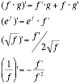

Let’s work with :

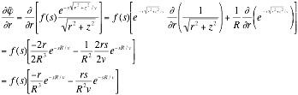

Now continue with :

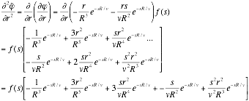

And  follows the same example:



Then:

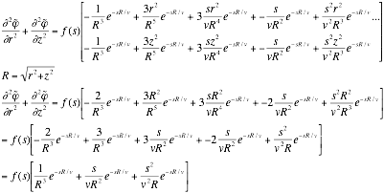

Then the complete expression is:



We need to come back to the expression: 

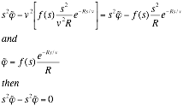

**Exercise 2**

*Determine the amplitudes of the components of the P and S waves, and the angles describing the wave propagation direction and particle motion.*



* Let’s start with the P wave: 



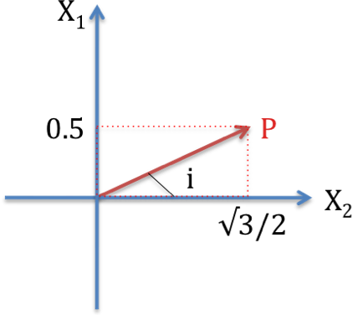Direction of the wave propagation:

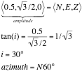

Particle motion: 

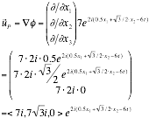

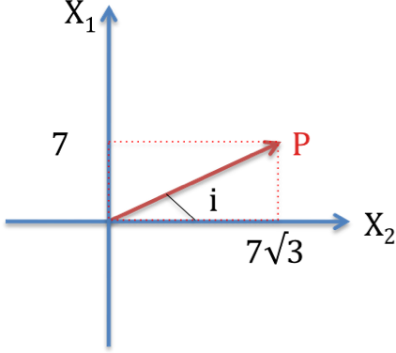but: 

We need to consider the real part only:



Thus:



tan(i)=7/(7√3)=1/√3

i=30° and azimuth=N60°

* For S wave



tan(i)=0.5/(√3/2)

i=30° and azimuth=N60°

Particle motion:

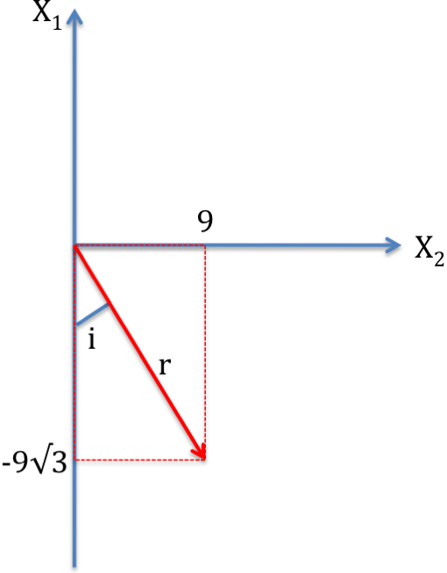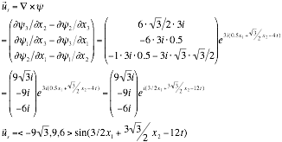

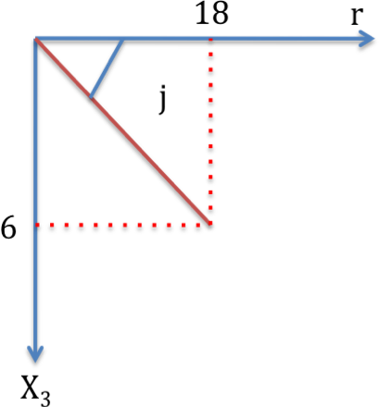tan(i)=9/(-9√3)=-1/√3

i=-30° => azimuth = N150°

r=√(92 + 92 . 3) = 18

tan(j) = 6 / 18 = 1/3

j ≈ 18.4° => dip, plunge

**Exercise 3**

*Given the amplitudes of the displacements for P and S waves as follows,*



*The velocities of the two waves are Vp=6km/s and Vs=4km/s, and the angular frequency is ω=4. Find the expressions for the potentials φ and ψi.*

* P-wave



Let’s consider: 

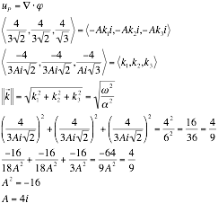

Return to:

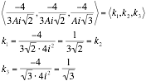

then:



* S-wave

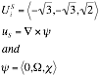

We can separate this S-wave:

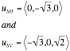

Let’s work with SV-wave first:

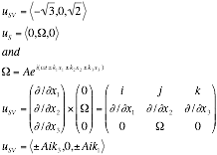

Take the modulus of the vector:

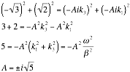

Then we can know the vector k:

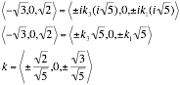

Now consider SH-wave:



Because X2 is perpendicular to u:

