Problem 1.

Indicator equation ( equation 5.4 in Lay and Wallace)

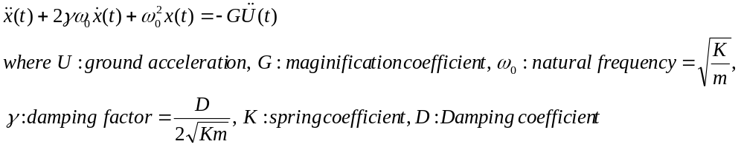
Because the natural frequency of the instrument is 0.1Hz and the mass is 0.1kg, the spring coefficient will be
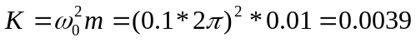
Unit of K is N/m

Problem 2.

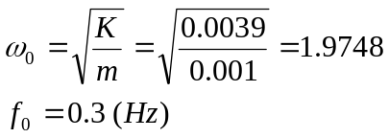

Reducing the mass keeping the same spring coefficient increases the natural frequency of the instrument. The response is now flat above 0.3Hz which means there is less sensitivity in the 0.1-0.3 Hz band than before.

Problem 3.

Amplitude response and Phase response for displacement;
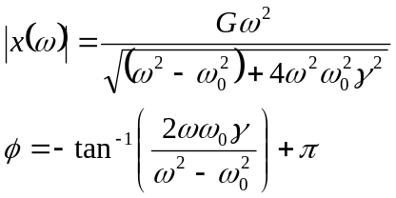

For problem 1 For problem 2
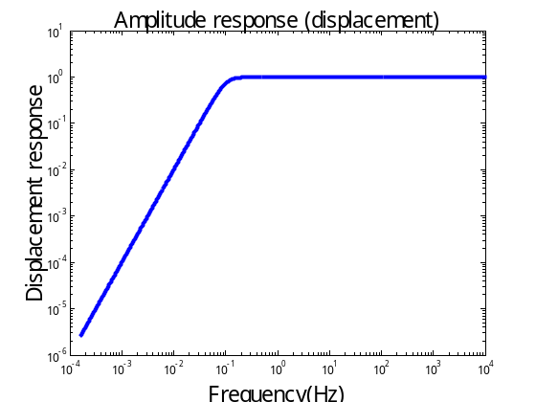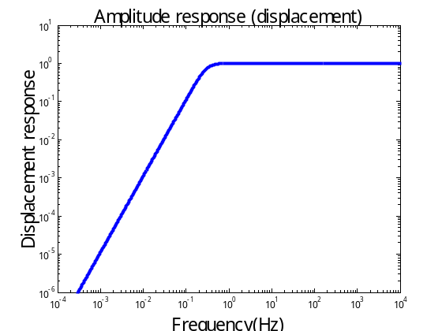

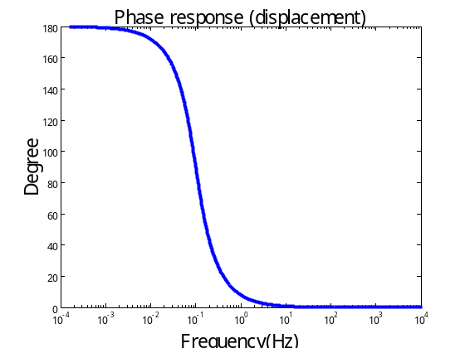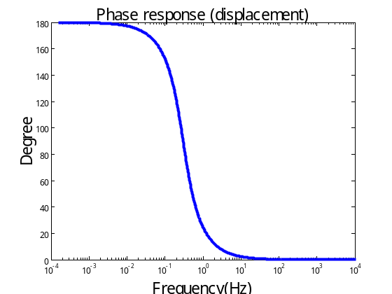
Amplitude response for acceleration;
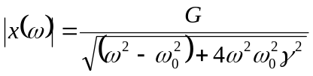
Phase response should be the same as that of displacement because 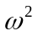is the real.

For problem 1 For problem 2
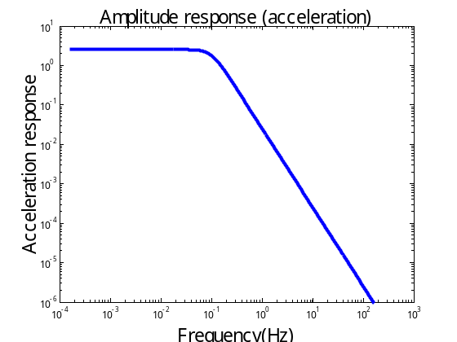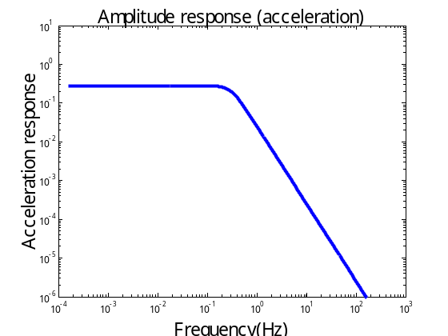

For the displacement response, the amplitude of the flat level doesn’t change with increasing natural frequency, but the effective recording range shift to higher frequency range.
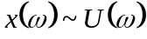
Smaller natural frequency has a wider effective recording range and it requires a large inertial mass.

For the acceleration response, amplitude of the response is inversely proportional to the square of the natural frequency of instrument, and the effective recording range shifts to a higher frequency range.
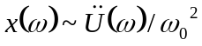
Smaller mass increases the natural frequency of the instrument and increases the effective recording range. But it also decreases the amplitude of the flat level.

Problem 4.

Broad-band data shows the clear S-wave and Love wave arrival. You can see the ramp-like phase arrival from P-S and S-Love wave, which is because of the head-wave.

Compared to the broadband record the;

Short period Wood-Anderson: clearly shows the more high frequency content, and clear P-wave arrival but it is hard to identify the direct S wave arrival and Surface wave phases.

Long-period Wood-Anderson: shows similar frequency content to the broadband record, but no ramp-like arrival. It shows a Love wave phase (longer period) and it seems that the predominant frequency of fundamental mode of Love wave must be similar to the predominant frequency of the instrument. The first shorter period S-wave is likely a Moho reflection (since a head wave is observed on other records), but more analysis is needed to definitively identify the phase.

Galitzen: Love wave shape looks similar to broadband record, but body waves are not well defined. There is a higher pre-P-wave noise level that persists through the record in contrast to the other instrument types. This suggests the noise level is higher in the Galitzen passband (see (A) below).

Press-Ewing: Doesn’t show body waves, and only long-period Love wave can be identified. The instrument removed (filtered) all of the high frequency content. Thus there is apparently very low levels of low frequency (lower than the Galitzen instrument) noise at this site.

The Love wave phase differs in each record because the ground-motions are filtered in a narrow frequency band and each instrument has a slightly different phase response in the passband.

(A).
The amplitude of earthquake spectrum is the displacement spectrum. The displacement spectrum is flat at low frequency and start to decay at the corner frequency with certain rate (e.g.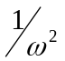). Because this spectrum is filtered, the amplitude of the low frequency part is cut. The noise amplitude decays linearly except at 0.1-0.2Hz band range. The high amplitude in 0.1-0.2 Hz is caused by the interaction between ocean swells and the coastline. The slope of decay of earthquake is steep compared to that of the noise.
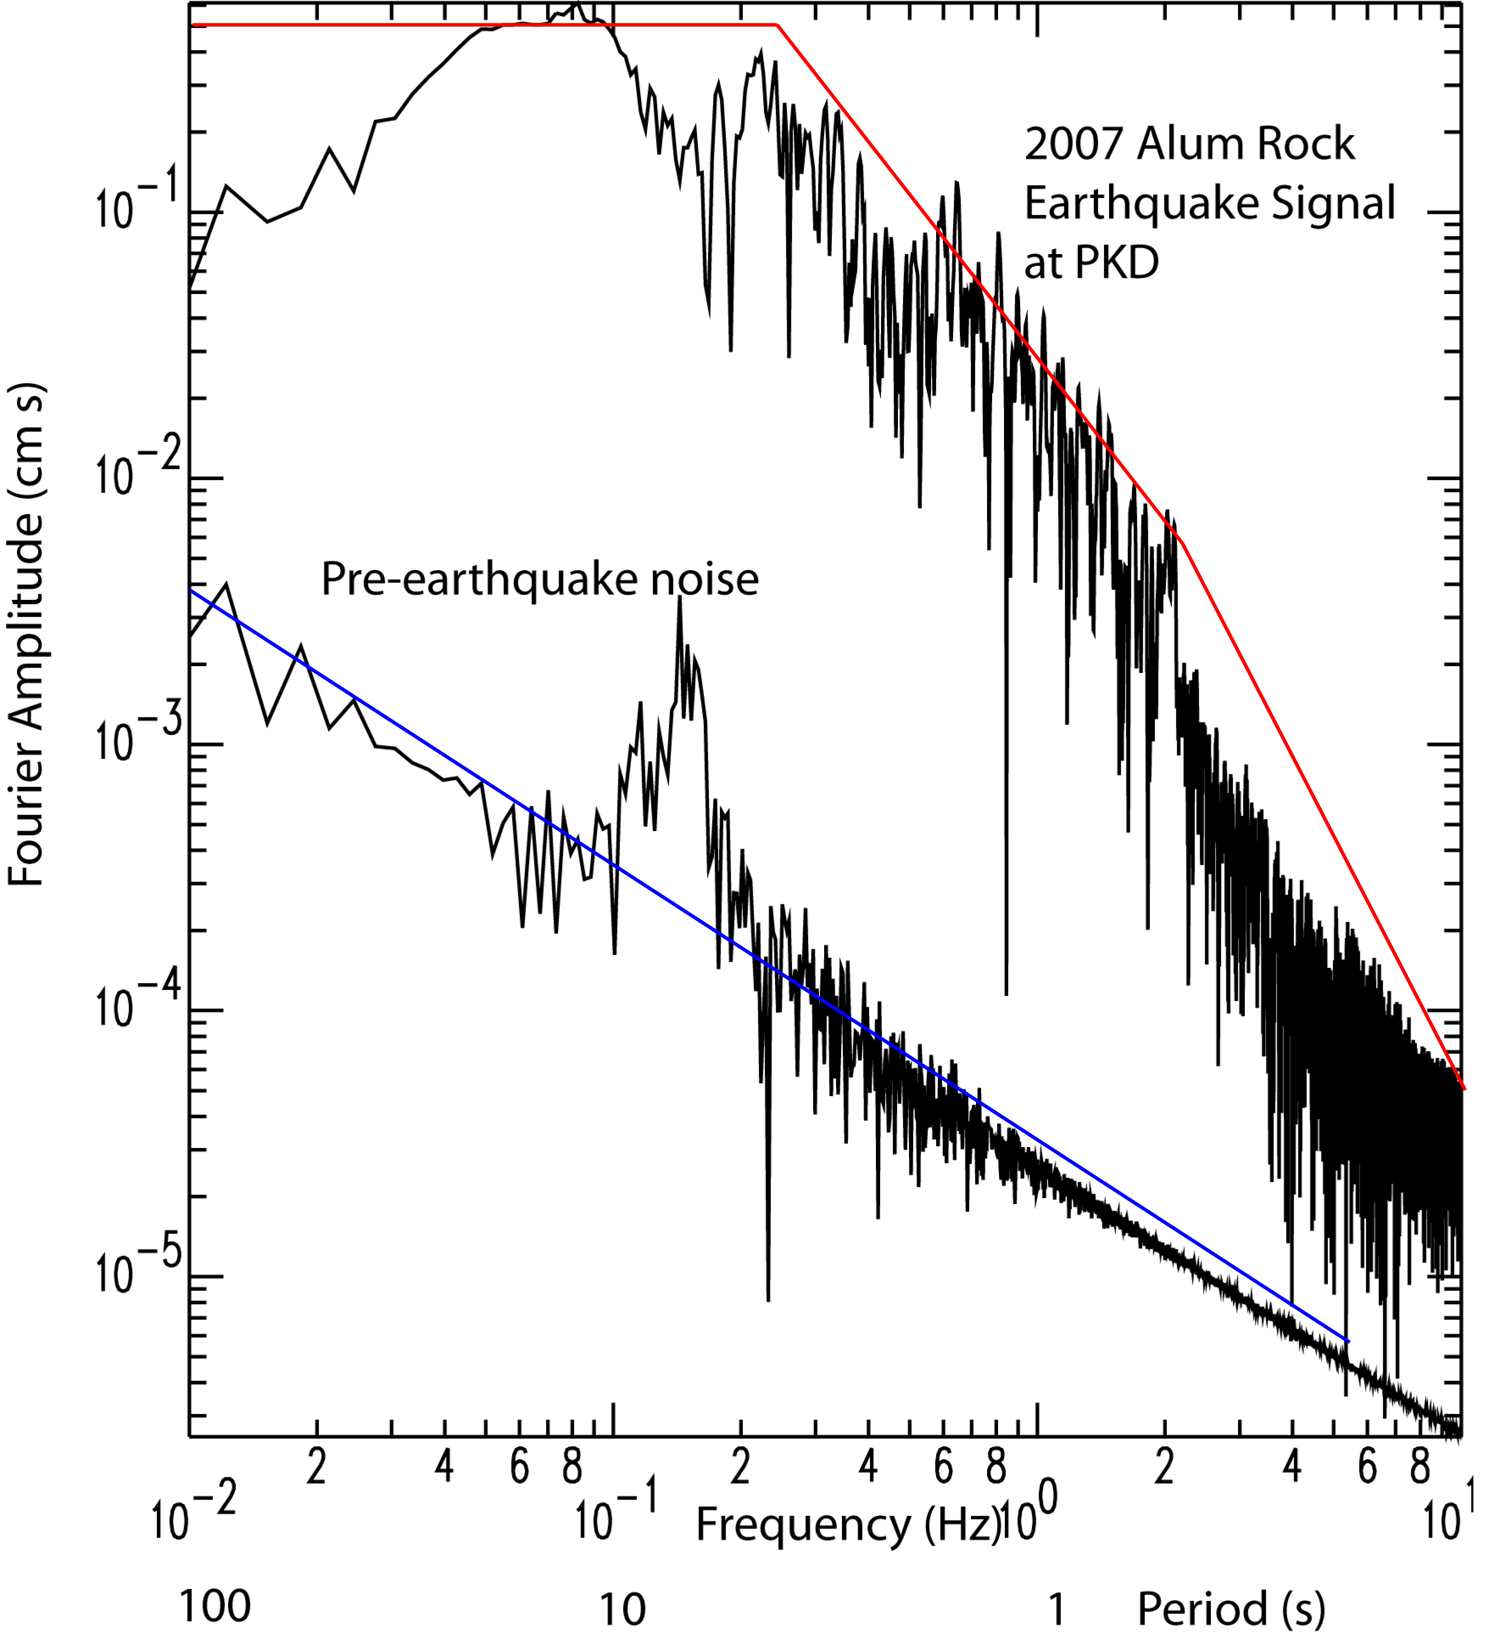
(B).
P can be pick easily using short period WA. S wave arrival can be picked from broad-band or/and Long-period WA. Love wave arrival is clear at Long-period arrival.
Because of the different frequency content, arrival time of each phases are slightly differ by records.

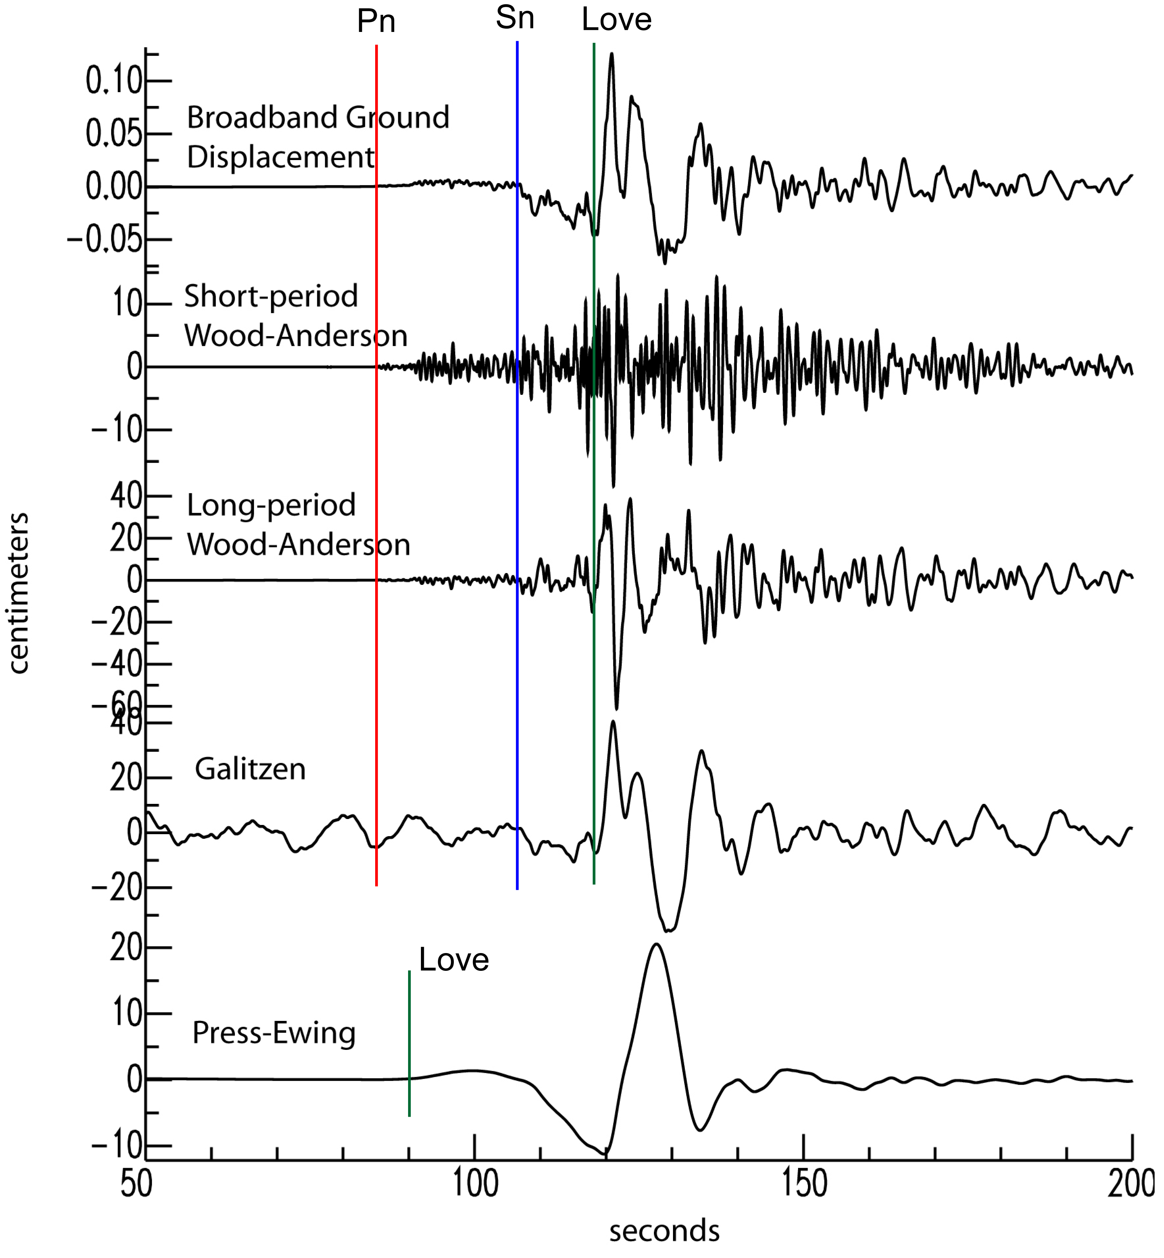

(C).
The dominant periods are estimated from the wavelength which has large amplitude (Love wave).
Broad band doesn’t have dominant period but the sensitivity is all same above natural frequency.
Short-period WA: 0.8 sec
Long-period WA: 5 sec
Galitzen: 10 sec
Press-Ewing: 30 sec
Natural frequency of the instrument is the inverse of dominant period for short period WA and long period WA. But for Galitzen and Press-Ewing, is it true? It turns out it is true. The natural periods of the SPWA, LPWA, Galitzen and PE are 0.8 sec, 6 sec, 12 sec, and 30 sec.

(D).
The predominant period of Galitzen is estimated as 10 sec in (C), which means that the instrument is sensitive to the noise at the 0.1Hz. As discussed in (A), the noise spectrum shows the high amplitude at 0.1-0.2Hz. The noise seen in the Galitzen must come from the frequency band. The source of the noise is interaction between ocean swells and the coastline.

